**Church Directory**

##### Staff

##### Pastor Rev. Bruce Brown

Office Administrator Dot Snyder

Preschool Director Isabelle Dontsop

Church Treasurer Earl Dove

Music Coordinator Brian Dove

Flower Coordinator Isabelle Dontsop

Prayer Chain Coordinator Brenda Anderson

###### Ruling Elders

Fred Entrekin 3/21 Elder

T. R. Hunter 3/21 Session Clerk

Joe Strube Elder Emeritus

**Deacons**

Earl Dove 10/20 Finance

Nelson Jenkins 3/21 Mercy

Johnny Wallace 3/21 Property

Raymond Wilson 3/21 Ushers, Property

**Missionaries**

Joe and Ann Lyle - MTW Taiwan

Larry and Sandra Rockwell–MTW Peru

Bill and Susan Carr – MTW Sioux Indians, MN

Michael and Lindie Wadhams-MTW Lummi Indians, WA

**Need to Reach Us?**

Rev. Bruce Brown ………………….………. [christshousehold@yahoo.com](mailto:christshousehold@yahoo.com)

[704-698-8009](tel:704-698-8009) cell

704-875-1182 ext. 6 church

Preschool….………………………..………….. Isabelle Dontsop - 704-947-0228

Dontsop cell 980-248-9306

E-mail……………………….…............ director@prosperitypreschool.com

Church Office…………………..…………..… 704-875-1182 Ext. 4

E-mail……………..…………..…………. [email@prosperitychurch.org](mailto:email@prosperitychurch.org)

Website…………………………………………. [WWW.prosperitypca.com](http://WWW.prosperitypca.com)

Church Office Hours………..………..…... Tues.-Fri. 8:00 AM-12:30 PM

Prayer Chain Coordinator………………..Brenda Anderson

704-875-2351 - [brendaea42@gmail.com](mailto:brendaea42@gmail.com)



**Alleluia! He is Risen.**

In the end of the Sabbath, as it began to dawn toward the first day of the week, came Mary Magdalene and the other Mary to see the sepulcher.

And, behold, there was a great earthquake: for the angel of the Lord descended from heaven, and came and rolled back the stone from the door, and sat upon it.

His countenance was like lightning, and his raiment white as snow:

And for fear of him the keepers did shake, and became as dead men.

And the angel answered and said unto the women, Fear not ye: for I know that ye seek Jesus, which was crucified.

**He is not here: for he is risen, as he said. Come, see the place where the Lord lay.**

# Matthew 28:1-6

**ANNOUNCEMENTS**

**Welcome to Prosperity Church Service!**

We warmly welcome you to the Prosperity Church Easter Worship Service. We are honored to share this morning service with you as we worship God's risen Son. May you know the love of God and feel His presence, for you are special to the Lord, and to us. We pray that God will touch your life during the service, and that you will know His peace.

**Our regular scheduled ministries and Bible Studies listed below will continue when the Coronavirus ban is over.**

**Inquirer’s Class**

**Adult and Youth Sunday School Classes**

**Ladies’ Wednesday Community Bible Study**

**Ladies’ Thursday Night Bible Study**

**Trail Life**

**The Wednesday Night Bible Study is scheduled for April 15 at 7:00 PM.** The study is in Romans. Pastor Bruce is the teacher.  Please check the latest emails and Facebook posts and Cloud HD Video to join our Bible study virtually until we can resume in person at the church. The Bible studies are also posted at [www.prosperitypca.com](http://www.prosperitypca.com)

**Below is a link to our Wednesday night Bible study.  We will be in the last half of Romans 10:5-13.**

Call in Wednesday April 15 around 6:55.

The number is (408) 638-0968.  Once you place your call you will be asked to enter the meeting ID #.  The ID # is 943 720 784.  After entering the ID # You will be asked to enter a participant ID - just skip this step by pressing the # button.  You can also join this meeting using your computer to join Zoom Meeting – via an Electronic Device (computer) https://us04web.zoom.us/j/943720784. The Meeting ID is 943 720 784.

**Church Calendar**

**Worship Service Sunday at 10:00 AM Video**

**Wed. Night Bible Study Wednesday April 15 at 7 PM Video**

**Church Families for Prayer**

**Sunday, April 12 Tom and Kelli Ellsworth Family**

**Monday, April 13 Fred Entrekin**

**Tuesday, April 14 Liliane and Kenneth Forlmu Family**

**Wednesday, April 15 Mark and Megan Gregory Family**

**Thursday, April 16 Cathee Griffin**

**Friday, April 17 Tim and Victoria Hanline Family**

**Saturday, April 18 Armando and Eunice Hernandez**



**Pray for our Missionaries**

**Michael and Lindie Wadhams,**

**Lummi Indians, WA**

The Wadham family serves with [MTW](https://www.mtw.org/missionaries/details/michael-and-lindie-wadhams) on the Lummi Indian Reservation. They were impressed by the Holy Spirit to minister to Native Americans. After serving on the Cherokee Reservation in North Carolina, they now serve the tribes between the Nooksack and Lummi reservations. They labor among the tribes through evangelism, developing discipleships and mentoring. Their long-term goal is to establish Native churches in the region. Please pray for their ministry.

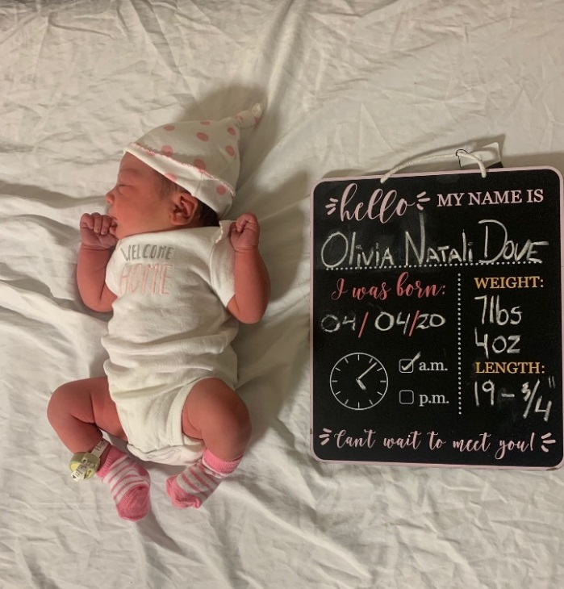

**Olivia Natali Dove**

Congratulations to Brian and Irina Dove on the birth of their daughter, Olivia Natali Dove. She was born Saturday, April 4. Olivia weighed 7 lbs. and 4 ozs. and was 19 ¾ inches in length. The family is now at home at 6823 Mcilwaine Road, Huntersville, NC 28078.