Church Directory

Staff

Pastor Rev. Bruce Brown
Office Administrator Dot Snyder
Preschool Director Isabelle Dontsop
Church Treasurer Earl Dove
Music Coordinator Brian Dove
Flower Coordinator Isabelle Dontsop
Prayer Chain Coordinator Brenda Anderson

Ruling Elders
Fred Entrekin 3/24 Elder
T. R. Hunter Inactive
Joe Strube Elder Emeritus
Deacons
Earl Dove 10/23 Finance
Johnny Wallace 3/24 Property
Raymond Wilson 3/24 Ushers, Property
Missionaries
Joe and Ann Lyle - MTW Taiwan
Larry and Sandra Rockwell–MTW Peru
Bill and Susan Carr – MTW Sioux Indians, MN
Michael and Lindie Wadhams-MTW Lummi Indians, WA
Shaun and Becky Hurrie – MTW South Africa

Need to Reach Us?

Rev. Bruce Brown ………………….………. christshousehold@yahoo.com

704-698-8009 cell

704-875-1182 ext. 6 church
Preschool….………………………..………….. Isabelle Dontsop - 704-947-0228
Dontsop cell 980-248-9306
E-mail……………………….…............ director@prosperitypreschool.com
Church Office…………………..…………..… 704-875-1182 Ext. 4
E-mail……………..…………..…………. email@prosperitychurch.org
Website…………………………………………. WWW.prosperitypca.com

Church Office Hours………..………..…... Tues.-Fri. 8:00 AM-12:30 PM
Prayer Chain Coordinator………………..Brenda Anderson
704-875-2351 - brendaea42@gmail.com

Welcome to Prosperity Church Service!

We warmly welcome you to the Prosperity Church Worship Service. We are honored to share this morning service with you as we worship God's risen Son. May you know the love of God and feel His presence, for you are special to the Lord, and to us. We pray that God will touch your life during the service, and that you will know His peace

Welcome
Rev. Steve McCullough

Steve serves as an Assistant Pastor at Grace Presbyterian Church (PCA) in Harrisburg. Steve was ordained in January 2021.
He and his wife Rachel were married in 2017. They have one son, Robert.

The National Day of Prayer is
May 6, 2021

Sunday Morning Worship Service
Prosperity’s online Worship Service is available, and is posted on our Facebook Page - Prosperity Presbyterian Church at 10 AM. To view the service through our website check out https://www.prosperitypca.com/worship-services or listen to the sermon audio at “The Apostle Paul, Chief of Sinners”—Prosperity PCA

Wednesday Night Bible Study
A new Wednesday Night Bible Study
will begin May 5, at 7:00 PM.
We will continue meeting in the sanctuary,
and the links will be the same.

Our new Wed. Bible Study will be Daniel: A 12-Week Study.
The main purpose of Daniel is to reveal to us who God is… his character, his purposes and his way of working in the world for the good of his people. The main lesson of Daniel is: Dare to trust in Daniel’s God.

Carpet Fund
Wonderful news! We are starting a Carpet Fund for purchasing new carpet for the sanctuary.
Please pray about this, and if you would like to give, make your check to the Carpet Fund and place it in the plate at the back of the church. If you have questions please contact Pastor Bruce or Earl Dove.

Trail Life
Troop 412 meets each Tuesday at 7:00 PM in the GYM. This is a Christ-centered outdoor program open to boys and young men aged 5-17. If you have questions please see Pastor Bruce.

Church Calendar
April 18, Sunday Worship Service at 10:00 AM
April 27, Tuesday Trail Life 7:00 PM

Church Families for Prayer
Sunday, April 18 Jackie, Olivia and Sam Clark
Monday, April 19 Carol Comer
Tuesday, April 20 Carolyn Davis
Wednesday, April 21 Isabelle Dontsop Family
Thursday, April 22 Brian and Irina Dove Family
Friday, April 23 Fred Entrekin
Saturday, April 24 Scott Flowers
Please pray for Raymond Wilson. His sugar medication is
causing a terrible upset stomach.
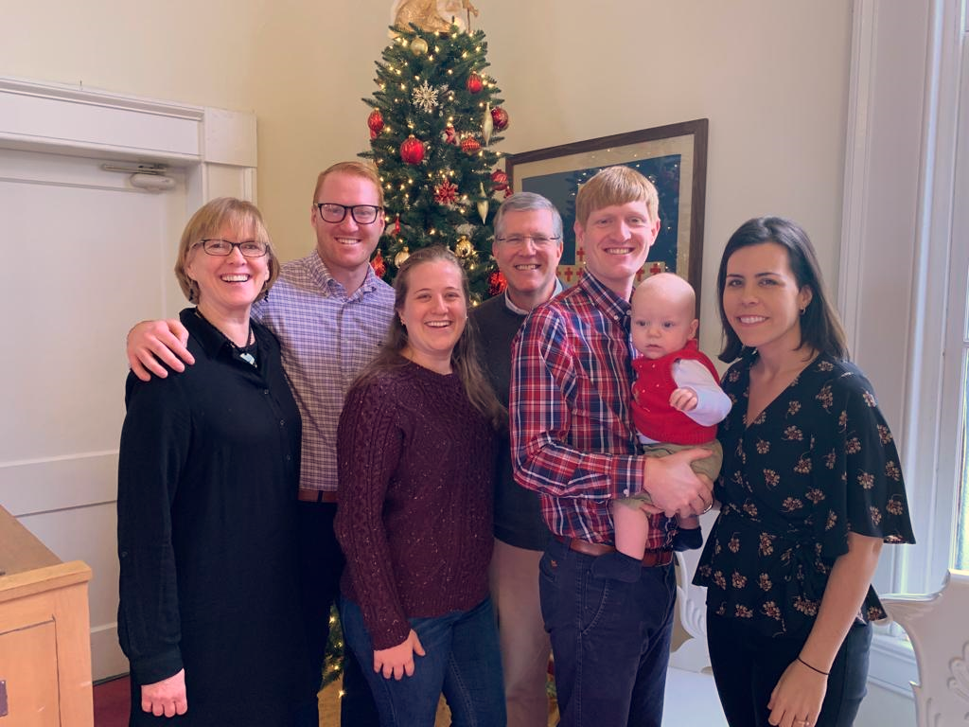
Pray for our Missionaries
Frank and Sheree, Middle East

Frank and Sheree have just completed their classes with the SYR refugees.
“Three to five people were unable to attend the classes because if they take time off from work, they would lose their job. They work 6 days a week and if they take time off, someone stands ready to take their job. Despite this, one young couple, have been believers for a little over 3 years. He was so hungry to attend classes, that he worked double shifts (16 hours/day) for 2 weeks, so that he could take off the week for study.
We had great fellowship with the highlight being the last night. We stayed up until 2:30 AM answering biblical and theological questions and discussing life and ministry. We had counseling with a young man who has gotten into debt because he lost his job.
Praise God for His Word that brings new life and deepens that life. Please pray for these SYR refugees that they will follow God’s leading and trust Him daily.”
Pray for Sheree as she reopens (again) the preschool this week. She is trying to balance people’s expectations, safety and keeping the children learning. Pray for wisdom, sensitivity and protection for all involved.
Frank and Sheree

