Worship Service

Prelude Lily Brown
Dawn Carpenter

Welcome and Announcements Rev. Bruce Brown

Hymn We Come, O Christ, to You #117

Call to Worship (from Psalm 86) Rev. Bruce Brown
Leader: We will praise you, O Lord our God, with our whole hearts; we will glorify your name forever; for you have delivered us from the power of death.
People: Bring joy to your servants, O Lord, for to you we lift up our souls. There is none like you; no deeds can compare with yours.
Leader: All the nations you have made will come and worship before you. They will bring glory to your name, for you alone are God.
All: Teach us now your way, O Lord, and we will live in your truth. Give us hearts that we may fear and praise your great name.

Hymn In Christ Alone Insert
Prayer Rev. Bruce Brown

The Lord’s Prayer Pastor and Congregation

Doxology #625

Special Music Lily Brown
Dawn Carpenter

God’s Word John 14:1-11

Message Comfort for Troubled Souls Rev. Bruce Brown

Hymn To God Be the Glory #66

Benediction Rev. Bruce Brown

Postlude Lily Brown
Dawn Carpenter

“Comfort for Troubled Souls”
Rev. Bruce Brown

John 14:1-11

I. Comfort for the Silent (verses 1-4)

II. Comfort for the Skeptic (verses 5-7)

III. Comfort for the Stranger (verses 8-11)

“Let us however take comfort in the simple truth, that Christ is very God of very God; equal with the Father in all things, and One with Him. He who loved us, and shed His blood for us on the cross, and bids us trust Him for pardon, is no mere man like ourselves. He is "God over all, blessed forever," and able to save to the uttermost the chief of sinners. Though our sins be as scarlet, He can make them white as snow. He that casts his soul on Christ has an Almighty Friend--a Friend who is One with the Father, and very God.” ~ J.C. Ryle

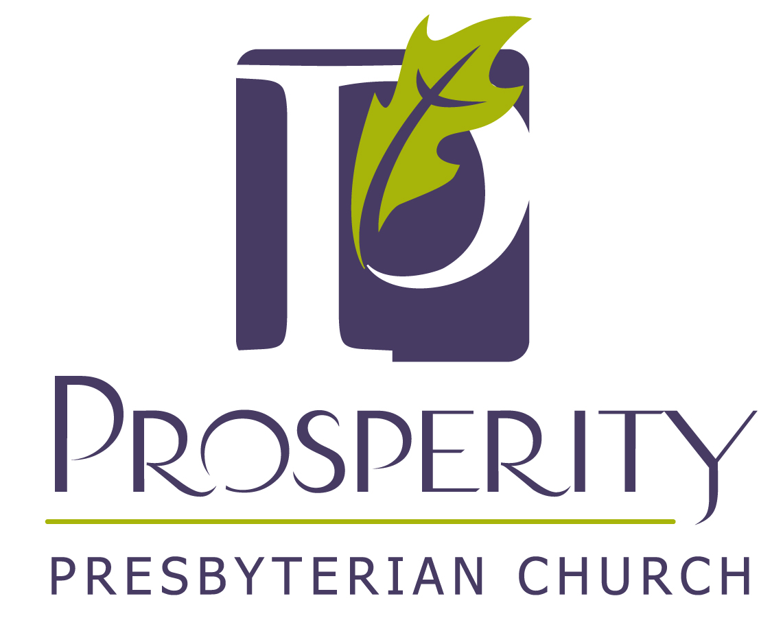

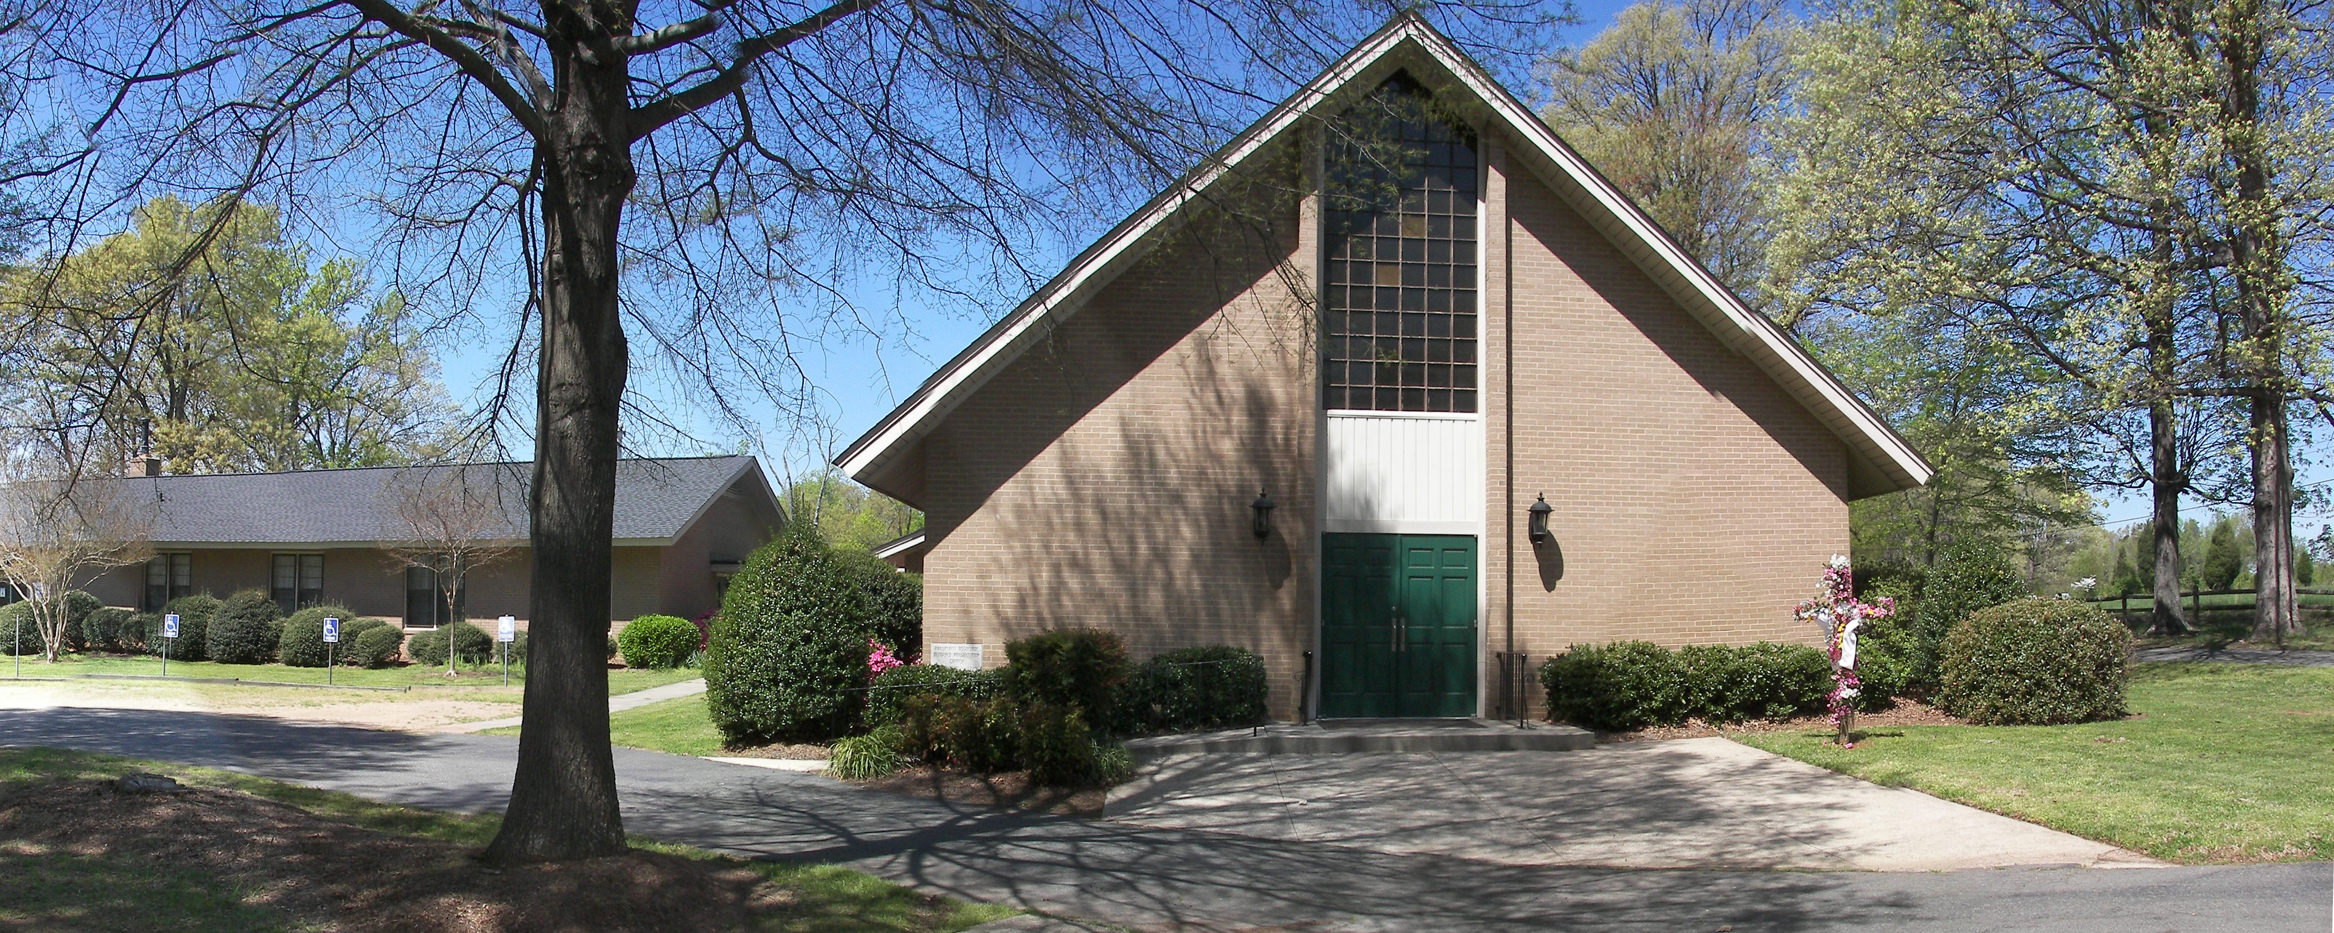

Learning to love God and share His Love.

April 19, 2020
10:00 AM Worship Service

Established in 1789

5533 PPC Drive
Charlotte, NC 28269

A Congregation of the Catawba Valley Presbytery
Presbyterian Church in America (PCA)

