**Church Directory**

##### Staff

##### Pastor Rev. Bruce Brown

Office Administrator Dot Snyder

Preschool Director Isabelle Dontsop

Church Treasurer Earl Dove

Music Coordinator Brian Dove

Flower Coordinator Isabelle Dontsop

Prayer Chain Coordinator Brenda Anderson

###### Ruling Elders

Fred Entrekin 3/21 Elder

T. R. Hunter 3/21 Session Clerk

Joe Strube Elder Emeritus

**Deacons**

Earl Dove 10/20 Finance

Nelson Jenkins 3/21 Mercy

Johnny Wallace 3/21 Property

Raymond Wilson 3/21 Ushers, Property

**Missionaries**

Joe and Ann Lyle - MTW Taiwan

Larry and Sandra Rockwell–MTW Peru

Bill and Susan Carr – MTW Sioux Indians, MN

Michael and Lindie Wadhams-MTW Lummi Indians, WA

**Need to Reach Us?**

Rev. Bruce Brown ………………….………. [christshousehold@yahoo.com](mailto:christshousehold@yahoo.com)

[704-698-8009](tel:704-698-8009) cell

704-875-1182 ext. 6 church

Preschool….………………………..………….. Isabelle Dontsop - 704-947-0228

Dontsop cell 980-248-9306

E-mail……………………….…............ director@prosperitypreschool.com

Church Office…………………..…………..… 704-875-1182 Ext. 4

E-mail……………..…………..…………. [email@prosperitychurch.org](mailto:email@prosperitychurch.org)

Website…………………………………………. [WWW.prosperitypca.com](http://WWW.prosperitypca.com)

Church Office Hours………..………..…... Tues.-Fri. 8:00 AM-12:30 PM

Prayer Chain Coordinator………………..Brenda Anderson

704-875-2351 - [brendaea42@gmail.com](mailto:brendaea42@gmail.com)

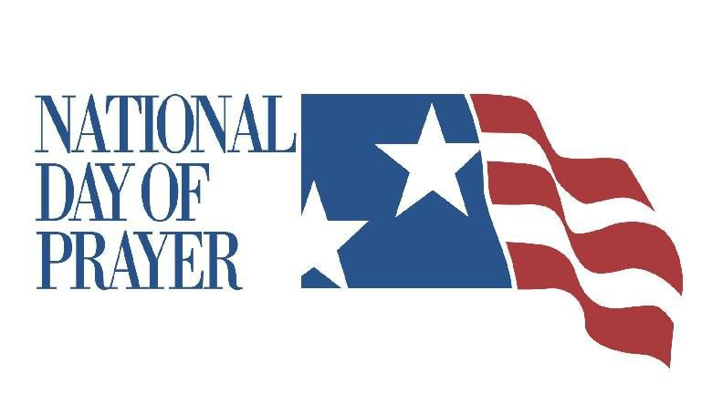

**National Day**

**of Prayer is**

**May 7, 2020**

**The National Day of Prayer theme this year is:**

# **Pray God’s Glory Across the Earth!**

Habakkuk 2:14

The National Day of Prayer was established by an act of Congress in 1952 and it has become a significant activity in the lives of millions of citizens, not only in America, but on military bases and at embassies around the world. Each year the President and all 50 Governors sign proclamations declaring the First Thursday in May as a day of prayer for our nation.

The National Day of Prayer Task Force's stated mission was to "communicate with every individual the need for personal repentance and prayer, mobilizing the Christian community to intercede for America and its leadership in the seven centers of power: **government, military, media, business, education, church and family.”**

**Scripture tells us again and again that our fervent prayer is effective. That our loving God respsonds to His children’s earnest pleas in mighty ways that avail much, and ultmately determine the course of history.**

**At this crucial time for our nation, we can do nothing more important than pray.**

***Plan now to participate in National Day of Prayer, May 7 by praying throughout the day, wherever you are.***

**ANNOUNCEMENTS**

**Welcome to Prosperity Church Service!**

We warmly welcome you to the Prosperity Church Worship Service. We are honored to share this morning service with you as we worship God's risen Son. May you know the love of God and feel His presence, for you are special to the Lord, and to us. We pray that God will touch your life during the service, and that you will know His peace.

**The Wednesday Night Bible Study is scheduled for April 29 at 7:00 PM.** The study is in Romans. Pastor Bruce is the teacher.  Please check the latest emails and Facebook posts and Cloud HD Video to join our Bible study virtually until we can resume in person at the church. The Bible studies are also posted at [www.prosperitypca.com](http://www.prosperitypca.com)

**Below is a link to our Wednesday night Bible study.**

**We will be in Romans 11:1-10**

Call in Wednesday April 29 around 6:55.

The number is (**408) 638-0968**.  Once you place your call you will be asked to enter the meeting ID #.  The ID # is **813 5756 6107**

After entering the ID # You will be asked to enter a participant ID - just skip this step by pressing the # button.

You can also join this meeting using your computer to join **Zoom** Meeting – via an Electronic Device (computer) The link is [**https://us02web.zoom.us/j/81357566107**](https://us02web.zoom.us/j/81357566107)

The Meeting ID is **813 5756 6107**.

**Our regular scheduled ministries and Bible Studies listed below will continue when the Coronavirus ban is over.**

**Inquirer’s Class**

**Adult and Youth Sunday School Classes**

**Ladies’ Wednesday Community Bible Study**

**Ladies’ Thursday Night Bible Study**

**Trail Life**

**Church Calendar**

**Worship Service Sunday at 10:00 AM Video**

**Wed. Night Bible Study Wednesday April 29 at 7 PM Zoom**

**Church Families for Prayer**

**Sunday, April 26 Eric, Mary Beth and Silas Miller**

**Monday, April 27 Tom and Vickie Monroe**

**Tuesday, April 28 Leah Brant Family**

**Wednesday, April 29 Nancy Nicas**

**Thursday, April 30 Olive McNeill**

**Friday, May 1 Joanne Perry**

**Saturday, May 2 Ron and Lucy Richmond**

**Please continually pray for**

**others in these uncertain days.**



**Pray for our Missionaries**

**Larry and Sandy Rockwell**

**Huaraz, Peru**

We have one intern (Zach) coming to serve this summer and are praying for one more to join him. Please pray for Zach as he is beginning to raise his support.

Larry made two trips to Yanama where he was able to re-connect with some of the folks he had shared Scripture with before and also met with new people that showed at least an initial desire to hear more. It is often so hard to gauge the impact these times are having in the hearts and lives of those with whom he shares. One of the biggest lessons we have learned in these 15 years is all that is necessary is to be faithful to do the next good thing the Lord puts before us and leave the results to Him.

We are so thankful for the safety God provides as we travel back and forth to the villages around Huaraz and Yanama. Please continue to pray for protection over our vehicle and for our safety.

*Larry and Sandy Rockwell*