**Church Directory**

##### Staff

##### Pastor Rev. Bruce Brown

Office Administrator Dot Snyder

Preschool Director Isabelle Dontsop

Church Treasurer Earl Dove

Music Coordinator Brian Dove

Flower Coordinator Isabelle Dontsop

Prayer Chain Coordinator Brenda Anderson

###### Ruling Elders

Fred Entrekin 3/21 Elder

T. R. Hunter 3/21 Session Clerk

Joe Strube Elder Emeritus

**Deacons**

Earl Dove 10/20 Finance

Nelson Jenkins 3/21 Mercy

Johnny Wallace 3/21 Property

Raymond Wilson 3/21 Ushers, Property

**Missionaries**

Joe and Ann Lyle - MTW Taiwan

Larry and Sandra Rockwell–MTW Peru

Bill and Susan Carr – MTW Sioux Indians, MN

Michael and Lindie Wadhams-MTW Lummi Indians, WA

**Need to Reach Us?**

Rev. Bruce Brown ………………….………. [christshousehold@yahoo.com](mailto:christshousehold@yahoo.com)

[704-698-8009](tel:704-698-8009) cell

704-875-1182 ext. 6 church

Preschool….………………………..………….. Isabelle Dontsop - 704-947-0228

Dontsop cell 980-248-9306

E-mail……………………….…............ director@prosperitypreschool.com

Church Office…………………..…………..… 704-875-1182 Ext. 4

E-mail……………..…………..…………. [email@prosperitychurch.org](mailto:email@prosperitychurch.org)

Website…………………………………………. [WWW.prosperitypca.com](http://WWW.prosperitypca.com)

Church Office Hours………..………..…... Tues.-Fri. 8:00 AM-12:30 PM

Prayer Chain Coordinator………………..Brenda Anderson

704-875-2351 - [brendaea42@gmail.com](mailto:brendaea42@gmail.com)

**Welcome to Prosperity Church Service!**

We warmly welcome you to the Prosperity Church Worship Service. We are honored to share this morning service with you as we worship God's risen Son. May you know the love of God and feel His presence, for you are special to the Lord, and to us. We pray that God will touch your life during the service, and that you will know His peace.

**Sunday Morning Worship Service**

Prosperity’s online Worship Service is available, and is posted on our [**Facebook Page - Prosperity Presbyterian Church**](https://www.facebook.com/Prosperity-Presbyterian-Church-275363616175410/) at 10 AM.  If you would like to view the service through our website or reference the service later check out <https://www.prosperitypca.com/worship-services>  or you can listen to the sermon audio at **Remember the Sabbath Day** [**— Prosperity PCA**](https://www.prosperitypca.com/from-the-pulpit)

**Wednesday Night Bible Study**

A new Wednesday night Bible Study will begin September 9th at 7:00 PM.  It will be a book study on the Apostle's Creed, the LORD's prayer and the 10 Commandments.  The book is entitled **"Growing in Christ"** by J. I. Packer.  Several copies have already been ordered.  Please contact the church office or pastor Bruce to reserve your copy. A $5.00 donation for the book is appreciated.

**Ladies’ Bible Studies**

**The Ladies’ Wednesday Community Bible Study and the Ladies’ Thursday Night Bible Study will not meet until January 2021. These Bible Studies are a very important part of Prosperity Church, and our ladies will miss meeting and the fellowship they have together. The Bible Studies were postponed because of COVID-19. Please pray this virus will soon come to an end.**

**ANNOUNCEMENTS**

**The next Wednesday Night Bible Study**

**is scheduled for August 26 at 7:00 PM.**

Pastor Bruce is teaching the Wednesday study from Romans. Please check the latest emails and Facebook posts and Cloud HD Video to join our Bible study virtually until we can resume in person at the church. The Bible studies are also posted at [www.prosperitypca.com](http://www.prosperitypca.com)

**Below is a link to our Bible study, and is in Romans 16:17-27.**

Call in Wed. August 26 around 6:55. The number is (**408) 638-0968**.

Once you place your call you will be asked to enter the meeting ID#.  The ID# is 220 654 4063**.** After entering the ID# You will be asked to enter a participant ID, just skip this step by pressing the # button.

You can also join this meeting using your computer to join **Zoom** Meeting – via an Electronic Device (computer)

The link is [**https://us02web.zoom.us/j/2206544063**](https://us02web.zoom.us/j/2206544063)

The Meeting ID is 220 654 4063

**Hope Street Food Pantry**

**Thank you** for helping fill up the Hope Street Barrel. The people truly appreciated everything. We no longer have the Barrel at our church, but we will continue collecting donations. If you would like to bring items for the Hope Street Food Pantry, you may do so. **Please bring your nonperishable items** and leave them in the narthex.

**The items most needed are:** Mac and Cheese, Ramen Noodles, Rice, Instant Mashed Potatoes, Canned Ravioli, Canned Soup, Dry Pasta, Pasta Sauce, Baby Wipes and size 5 and 6 diapers.See Lucy Richmond for additional information.

* **Trail Life, Troop 412 meets Tuesday at 7:00 PM outside the GYM.** Open to boys ages 5-17. For information see Pastor Bruce.

* **The Adult / Youth Sunday School classes plan to continue safely in the months to come.**

**Church Calendar**

**Worship Service Aug. 23 Sunday at 10:00 AM Church Sanctuary**

**Trail Life Tuesday, Aug. 25, 7 PM Meeting outside at picnic area**

**Wed. Night Bible Study Wednesday Aug. 26 at 7 PM Zoom**

**Church Families for Prayer**

**Sunday, Aug. 23 Brian and Irina Dove Family**

**Monday, Aug. 24 Earl and Polly Dove**

**Tuesday, Aug. 25 Leah Brant Family**

**Wednesday, Aug. 26 Tom and Kelli Ellsworth Family**

**Thursday, Aug. 27 Fred Entrekin**

**Friday, Aug. 28 Liliane Forlemu Family**

**Saturday, Aug. 29 Mark and Megan Gregory Family**

**Pray for our Missionaries - Joe and Ann Lyle - Taiwan**

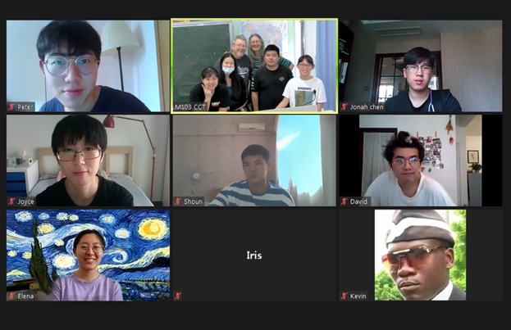

**This Fall at Christ’s College** Teachers are considering hybrid classes as they prepare for the fall semester. We are brainstorming how to best teach with half of our students in the classroom and half of them online at the same time. Freshman English teachers (like Joe) are particularly concerned with not only teaching the course content, but more importantly getting to really know the students. **Pray for wisdom and creativity.**

**David and Susanna Nam** (MTW missionaries planning to come this fall) have recently applied for a special entry visa. Taiwan is giving very few visas now. **Pray with us that God will guide the process and get them here.**

**Encouragement** - Last week, several alumni from 20 years ago visited campus. In our conversation, one mentioned that in my freshman conversation class, I had the students memorize Psalm 23. After she graduated, she went to the US and earned her MA and PhD degrees. She said that during the rough times, remembering Psalm 23 would give her strength. All three students expressed thanks for the help and love they received from the missionaries. (It was a little like having your grown children come back and thank you for being a good parent.)