**Church Directory**

##### Staff

##### Pastor Rev. Bruce Brown

Office Administrator Dot Snyder

Preschool Director Isabelle Dontsop

Church Treasurer Earl Dove

Music Coordinator Brian Dove

Flower Coordinator Isabelle Dontsop

**Ruling Elders**

Fred Entrekin 3/24 Elder

Brian Dove 9/24 Elder – Session Clerk

T. R. Hunter Inactive

Joe Strube Elder Emeritus

**Deacons**

Earl Dove 10/23 Finance

Johnny Wallace 3/24 Property

Raymond Wilson 3/24 Ushers, Property

Ron Richmond 9/24 Mercy

**Missionaries**

Larry and Sandra Rockwell–MTW Huaraz, Peru

Bill and Susan Carr – MTW Sioux Indians, MN

Michael and Lindie Wadhams-MTW Lummi Indians, WA

Shaun and Becky Hurrie – MTW South Africa

Frank and Sheree Newell – MTW Middle East

Will and Martha Faires – Myanmar, Burma - Equipping Leaders

Andrew Goyzueta – RUF Davidson College

**Need to Reach Us?**

Rev. Bruce Brown ………………………… [christshousehold@yahoo.com](mailto:christshousehold@yahoo.com)

[704-698-8009](tel:704-698-8009) cell

704-875-1182 ext. 6 church

Isabelle cell 980-248-9306

E-mail……………………….….................. director@prosperitypreschoChurch Office…………………..……………………..… 704-875-1182 Ext. 4

E-mail……………..…………..…………..…… [email@prosperitychurch.org](mailto:email@prosperitychurch.org)

Website………………………………………… [WWW.prosperitypca.com](http://WWW.prosperitypca.com)

Church Office Hours………..………..…. Tues.-Fri. 8:00 AM-12:30 PM

**Welcome to Prosperity Church Service!**

**We warmly welcome you to the Prosperity Church Worship Service. We are honored to share this morning service with you as we worship God's risen Son. May you know the love of God and feel His presence, for you are special to the Lord, and to us. We pray that God will touch your life during the service, and that you will know** **His peace.**



**Sunday School**

Beginning next Sunday Aug. 14 at 9 AM you can put Pastor Bruce and Richard Altork on the HOT SEAT

Send questions to Bruce [**christshousehold@yahoo.com**](mailto:christshousehold@yahoo.com)**;**

Or Richard Altork- [**rfabeliever@gmail.com**](mailto:rfabeliever@gmail.com)**.**

Or you can bring and ask questions in the class.

9:00 AM

**Sunday School Breakfast Kick Off**

We had a wonderful time at our Sunday School Kick off. The food was very delicious and the fellowship was great.

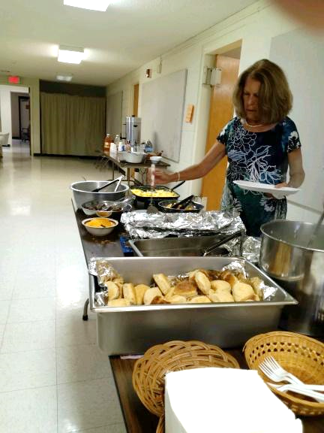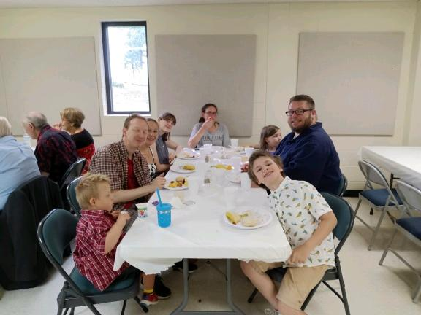



**Happy Birthday Jim!**

**Myra and Betty gave Jim and Brenda a**

**Birthday Cake and delicious meal**

**for Jim’s birthday.**

**Please continue praying for Brenda’s health.**

**Deacon’s Fund Sunday, August 7.**  The first Sunday of each month is designated as the Deacon’s Fund Sunday. Please mark your check for the Deacon’s Fund and place it in the plate as it is passed around.

**Officer’s Training Class**

**Our next meeting will be Wednesday, August 10,**

**at 6:00PM in the pastor's study.**

**Pray for Our Missionaries**

**Bill and Susan Carr**

**Sioux Indians, MN**

We are with the IMnA (Indigenous Ministries of North America). We are a church planting and church facilitating arm of MTW (Mission to the World). Simply put, our goal is to see the church grow among Native Americans of the United States and First Nations Peoples of Canada. Our goal is not just to plant churches, but to see healthy, God-glorifying congregations led by trained local leadership. All activities that we are involved in, directly or indirectly, are to see the church grow. In every instance, our job, as MTW, is to work ourselves out of a job and hand over the reins of the congregations to indigenous under-shepherds at the proper time in a smooth, natural, transition. IMnA organized as a region in August of 2017 at a special Washington-state gathering among MTW missionaries and National Partners.

****We thank the Lord that we were able to represent IMnA with two booths at our General Assembly. Patrick and Regina Lennox, Scott Hill, and I were there. As teaching elders, Scott, Patrick, and I were able to attend the assembly and vote on issues. We thank the Lord that Little Elk has returned from his studies in Israel. He will continue his academic studies, but is developing a ministry called Warriors Rise, which combines the gospel message and archery training. Would you consider partnering with him? If so, please contact me at [firestorm.mmc@gmail.com](mailto:firestorm.mmc@gmail.com)*. Bill and Susan Carr*

**Scott Hill and Bill at General Assembly**

**Church Calendar**

**Aug. 7 Sun. Worship Service 10:00 AM**

**Aug. 7 Sun. Sunday School 8:55 AM**

**Aug. 7 Deacon’s Fund Sunday**

**Aug. 9, Tue. Trail Life 7:00 PM**

**Aug. 10, Wed. Officer’s Training Class 6 PM**

**Church Families for Prayer**

**Sunday, Aug. 7 Carolyn Davis**

**Monday, Aug. 8 Isabelle Dontsop and Family**

**Tuesday, Aug. 9 Earl and Polly Dove**

**Wednesday, Aug. 10 Brian Dove Family**

**Thursday, Aug. 11 Caleb and Brook Eldridge Family**

**Friday, Aug. 12 Tom and Kelli Ellsworth Family**

**Saturday, Aug. 13 Fred Entrekin**

**\* Please pray for T. R. and Alma Hunter** for their health and upcoming transitions. Help them to know God’s direction and peace in their lives.

**\* Please pray for Peter Ellsworth.** His procedure date is Aug. 15 to increase blood flow in a pulmonary artery.

**\* Continue to pray for *JoAnne Perry, Josie Barbee, Cathee Griffin****,* ***Bernard Tilanus, Brenda Anderson and others.***

**Volunteers Urgently Needed After Deadly Kentucky Flooding**

Catastrophic flash floods swept through eastern Kentucky last week, destroying hundreds of homes, dozens of roads and bridges, and claiming at least 35 lives. Thousands of people are displaced and many are still missing.

Samaritan's Purse is deploying to two of the hardest-hit areas—Breathitt County and Floyd County—following the devastation.  We urgently need men and women who are willing to be the hands and feet of Christ If you would like to serve in Jesus' Name and help those who are hurting know that God loves them and hasn't forgotten them, go to[**SPVolunteer.org**](https://links.samaritanspurse.mkt5705.com/ctt?ms=MzQ0Mjg1NTES1&kn=10&r=MjI0OTgwMjQzMzY3S0&b=0&j=MjI0MzAzNDg5MgS2&mt=1&rt=0) to sign up.  Contact Ron and Lucy Richmond for more information 704-345-2250.

**Online Worship Service**

**Prosperity’s online Worship Service** is available, and is on our **Facebook Page - Prosperity Presbyterian Church** at 10 AM. To view the service through our website check out <https://www.prosperitypca.com/worship-services>  or listen to the sermon audio at **“**God’s Provision for Godly Living**”**[**Prosperity PCA**](https://www.prosperitypca.com/from-the-pulpit)