**Church Directory**

##### Staff

##### Pastor Rev. Bruce Brown

Office Administrator Dot Snyder

Preschool Director Isabelle Dontsop

Church Treasurer Earl Dove

Music Coordinator Brian Dove

Flower Coordinator Isabelle Dontsop

Prayer Chain Coordinator Brenda Anderson

###### Ruling Elders

Fred Entrekin 3/24 Elder

Brian Dove 9/24 Elder – Session Clerk

T. R. Hunter Inactive

Joe Strube Elder Emeritus

**Deacons**

Earl Dove 10/23 Finance

Johnny Wallace 3/24 Property

Raymond Wilson 3/24 Ushers, Property

Ron Richmond 9/24 Mercy

**Missionaries**

Joe and Ann Lyle - MTW Taiwan

Larry and Sandra Rockwell–MTW Peru

Bill and Susan Carr – MTW Sioux Indians, MN

Michael and Lindie Wadhams-MTW Lummi Indians, WA

Shaun and Becky Hurrie – MTW South Africa

**Need to Reach Us?**

Rev. Bruce Brown ………………….………. [christshousehold@yahoo.com](mailto:christshousehold@yahoo.com)

[704-698-8009](tel:704-698-8009) cell

704-875-1182 ext. 6 church

Preschool….………………………..………….. Isabelle Dontsop - 704-947-0228

Dontsop cell 980-248-9306

E-mail……………………….…............ director@prosperitypreschool.com

Church Office…………………..…………..… 704-875-1182 Ext. 4

E-mail……………..…………..…………. [email@prosperitychurch.org](mailto:email@prosperitychurch.org)

Website…………………………………………. [WWW.prosperitypca.com](http://WWW.prosperitypca.com)

Church Office Hours………..………..…... Tues.-Fri. 8:00 AM-12:30 PM

Prayer Chain Coordinator………………..Brenda Anderson

704-875-2351 - [brendaea42@gmail.com](mailto:brendaea42@gmail.com)

**Welcome to Prosperity Church Service!**

**We warmly welcome you to the Prosperity Church Worship Service. We are honored to share this morning service with you as we worship God's risen Son. May you know the love of God and feel His presence, for you are special to the Lord, and to us. We pray that God will touch your life during the service, and that you will know** **His peace.**

**Christmas Eve Candlelight Worship Service**

**Friday, December 24**

**at 5:00 PM**



**Christmas Hymns, Scripture Readings**

**Lighting the White Advent Candle**

**Lighting the Congregational Candles**

**Christmas Message from Pastor Bruce**

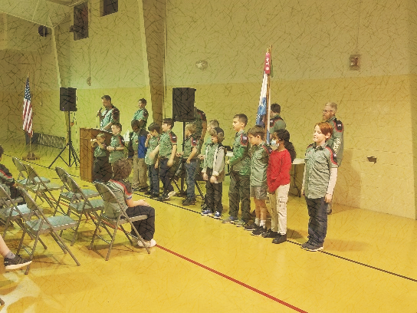**Trail Life had its** Court of Honor and Advancement Ceremony Awards this past Tuesday, December 14.

**Trail Life, Troop 412 meets each Tuesday at 7:00 PM in the GYM.** Open to boys ages 5-17. For information see Pastor Bruce. The next meeting is January 4.

**Communion will be observed January 9, 2022.**

**Prosperity’s Yearly Congregational Meeting will be scheduled for the end of January 2022, immediately following the 10 AM Worship Service.**

**The nominations for elders and deacons will begin soon. Please pray about the men to nominate.**

**Wednesday Bible Study**

The Wednesday Bible Study is on a short Christmas break. We will resume meeting in the sanctuary January 19th, 2022 and continue studying “Gentle and Lowly” chapters 19-23.

**Prosperity’s online Worship Service** is available, and is on our **Facebook Page - Prosperity Presbyterian Church** at 10 AM. To view the service through our website check out <https://www.prosperitypca.com/worship-services>  or listen to the sermon audio at **“Praise for the Loyal Love of God”** [**Prosperity PCA**](https://www.prosperitypca.com/from-the-pulpit)**.**

**Our Blood Drive last Wednesday** was very successful; we met our goal of 15 donations. This was enough to save 30 lives. Thank you!

**The American Heritage Girls** meets the 1st, 3rd, and 5th Thursdays of each month at 7:00 PM in the GYM. The next meeting is January 6.

**Please pray for Rev. Richard Altork.** He is now home from the hospital, and feels much better. Thankfully, his breathing and kidney function improved through hydration and medicine.  Continue to pray for him.

**Church Calendar**

**Dec. 19 Sunday Worship Service**

**Dec. 24, 2021 Friday Christmas Eve Service 5:00 PM**

**January 4, 2022 Tuesday Trail Life 7:00 PM**

**January 6, 2022 Thursday American Heritage Girls**

**January 2022 Sunday School 9:00 AM**

**January 19, 2022 Wed. Bible Study**

**Church Families for PrayeR**

**Sunday, Dec. 19 Olivia Clark**

**Monday, Dec. 20 Jackie Clark**

**Tuesday, Dec. 21 Carol Comer**

**Wednesday, Dec. 22 Janice Connell**

**Thursday, Dec. 23 Carolyn Davis**

**Friday, Dec. 24 Isabelle Dontsop and Family**

**Saturday, Dec. 25 Inez Brown**

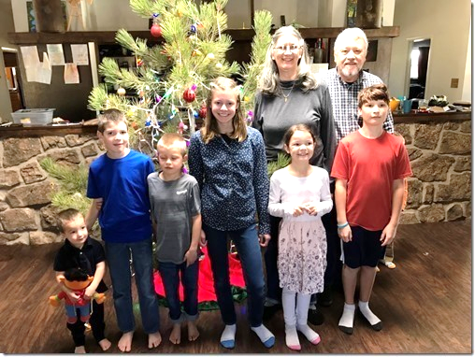

**Pray for Our Missionaries**

**Joe and Ann Lyle**

**30 Years Serving in Christ’s College, Taiwan**

“During the last 3 months, our time has been filled with visiting family, friends and churches. We are sharing about the ministry at Christ’s College what God has been doing there, and encouraging prayer for the ongoing work. We have also been relearning how to navigate living in the US. It costs more to live here. When not visiting we have an apartment in the Columbia, SC area. During Christmas we will be in California with our children and 6 grandchildren.

**Prayer for Christ’s College**

1. Pray for transition in leadership. Christ’s College has a new President (2/2022), a new Academic Dean, a new Dean of Student Affairs, and a new director of Human Resources.

2. For God’s guidance for the administration, staff, faculty, and board

3. For a revival on campus and a renewed vision to seek God first

4. For God to raise up new missionaries to minister at Christ’s College

**Prayer for Joe and Ann**

1. Continued adjustment to living in the US

2. Good connection with supporters and churches.

3. Renewed relationships with family.”

***We wish you all a Merry Christmas and a joyous celebration of Christ’s birth.*** ***Joe and Ann***