**Church Directory**

##### Staff

##### Pastor Rev. Bruce Brown

Office Administrator Dot Snyder

Preschool Director Isabelle Dontsop

Church Treasurer Earl Dove

Music Coordinator Brian Dove

Flower Coordinator Isabelle Dontsop

Prayer Chain Coordinator Brenda Anderson

###### Ruling Elders

Fred Entrekin 3/24 Elder

Brian Dove 9/24 Elder – Session Clerk

T. R. Hunter Inactive

Joe Strube Elder Emeritus

**Deacons**

Earl Dove 10/23 Finance

Johnny Wallace 3/24 Property

Raymond Wilson 3/24 Ushers, Property

Ron Richmond 9/24 Mercy

**Missionaries**

Joe and Ann Lyle - MTW Taiwan

Larry and Sandra Rockwell–MTW Peru

Bill and Susan Carr – MTW Sioux Indians, MN

Michael and Lindie Wadhams-MTW Lummi Indians, WA

Shaun and Becky Hurrie – MTW South Africa

**Need to Reach Us?**

Rev. Bruce Brown ………………….………. [christshousehold@yahoo.com](mailto:christshousehold@yahoo.com)

[704-698-8009](tel:704-698-8009) cell

704-875-1182 ext. 6 church

Preschool….………………………..………….. Isabelle Dontsop - 704-947-0228

Dontsop cell 980-248-9306

E-mail……………………….…............ director@prosperitypreschool.com

Church Office…………………..…………..… 704-875-1182 Ext. 4

E-mail……………..…………..…………. [email@prosperitychurch.org](mailto:email@prosperitychurch.org)

Website…………………………………………. [WWW.prosperitypca.com](http://WWW.prosperitypca.com)

Church Office Hours………..………..…... Tues.-Fri. 8:00 AM-12:30 PM

Prayer Chain Coordinator………………..Brenda Anderson

704-875-2351 - [brendaea42@gmail.com](mailto:brendaea42@gmail.com)

**We are thankful for God’s care**

**over Prosperity Church for the past 232 years.**



**Neighbors inspect ruins of Prosperity Church which was**

**destroyed by fire early Christmas Morning 1970.**

**This article is from the Davidson newspaper Thursday,**

**December 31, 1970 and the Charlotte Observer.**

The historic Prosperity Presbyterian Church building was destroyed by early morning fire Christmas morning 1970. The building was burned to the ground; only a small frame building, erected separately from the main plant to serve as a fellowship hall, was saved. Six volunteer fire departments answered the 3:00 am alarm and fought the fire. The building burned in less than an hour.

A portion of the destroyed structure was erected in 1849. The white frame sanctuary was the third building used by the congregation which was organized in 1789.

Prosperity’s first congregational meeting was held in a log cabin. The first building collapsed under the weight of a heavy snowfall in 1876. Construction began on a new church which was completed in 1889. Remodeling was done in 1924 and a new Sunday School addition was finished in 1954, according to church historian, Mrs. M. B. Wallace of Eastfield Road.

After the fire the Prosperity congregation, with a membership of 137 members, began meeting in a Derita funeral home. “A church is more than just a building, more than just a list of names.” Prosperity’s supply preacher told the congregation Sunday morning. “Now you, at present, do not have a church building, but you are a church just as surely as if you had the finest building in the land,” said Rev. Kenneth Seawright.

Rev. Seawright, a retired A.R.P minister, preached from the pulpit of a spacious chapel of McEwen Funeral Home on Mallard Creek Road at the northeast Mecklenburg County community of Derita.

**Welcome to Prosperity Church Service!**

**We warmly welcome you to the Prosperity Church Worship Service. We are honored to share this morning service with you as we worship God's risen Son. May you know the love of God and feel His presence, for you are special to the Lord, and to us. We pray that God will touch your life during the service, and that you will know** **His peace.**

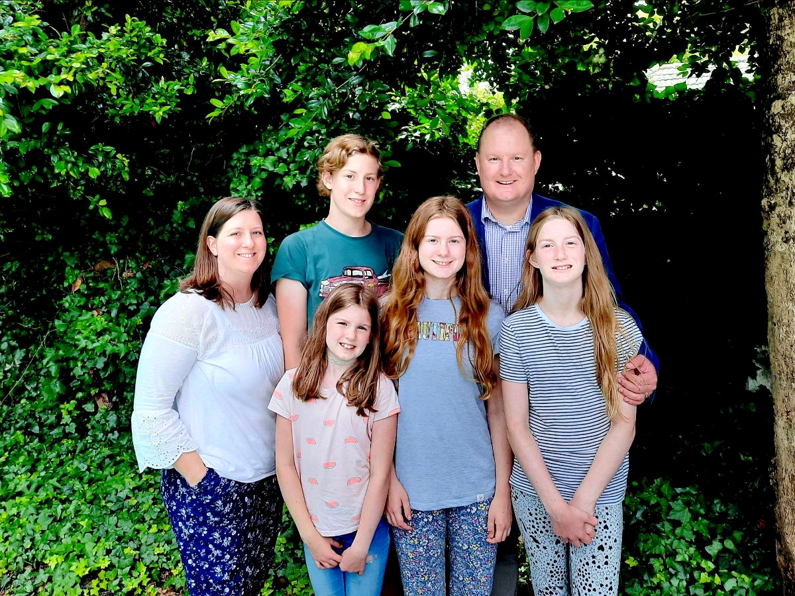

**Pray for Our Missionaries**

**Shaun, Becky Hurrie and Family, South Africa**

“Recently we got to visit Langa Life Bible Church as we had been hoping to do. What a joyous time of worship together; and quite a new experience for our entire family. This church is really a light for the Gospel in the Langa community which lacks sound Biblical exposition and has been hit hard by Covid. Our brothers and sisters there need our prayers.

In another adjacent township, Guguletu, our whole family had the opportunity to visit with Pastor Walter, his wife Thandi, and one of their daughters. He is the Pastor of Faithway Bible Church, and she is a nurse with wide-ranging experience, but now focused largely on the maternity side of things. Our basic purpose for going was to learn from them about both spirituality and healthcare in the townships respectively. While distinct, we received a firsthand experience in an area where these two issues overlap - the sangoma. Their property is surrounded by a number of local sangomas, but the closest one next door began a traditional healing ceremony right in the midst of our time with them. Indeed, healthcare for many people often begins with the sangoma before going to the hospital if no cure is available. This was both an experience and a learning opportunity for us and our kids as Pastor Walter outlined basically what they were doing and how contrary to the Gospel the practice is. We were so grateful for our time with them.” *Shaun Hurrie*

**To my church family at Prosperity: Thank you for all your prayers, and warm encouraging communications. I have received more Christmas cards from you in the past two weeks than I have in the past ten years – combined! I have read each and every one of them a number of times – and I cherish your prayers. Especially with all the medical struggles I have had, in and outside of the hospital, you have warmed my heart considerably. May our Heavenly Father warm your hearts for such kindness, in the name of our Lord and Savior, Jesus Christ. Richard  Altork**

**Church Calendar**

**January 2, Sun. Worship Service**

**January 4, Tue. Trail Life 7:00 PM**

**January 6, Thur. American Heritage Girls 7:00 PM**

**January 9, Sun. Communion**

**January 16, Sun. Sunday School 9:00 AM**

**January 19, Wed. Wed. Bible Study**

**January 30, Sun Yearly Congregational Meeting**

**Church Families for Prayer**

**Sunday, Dec. 26 Brian and Irina Dove Family**

**Monday, Dec. 27 Earl and Polly Dove**

**Tuesday, Dec. 28 Caleb and Brook Eldridge Family**

**Wednesday, Dec. 29 Tom and Kelli Ellsworth Family**

**Thursday, Dec. 30 Fred Entrekin**

**Friday, Dec. 31 Scott and Leah Flowers Family**

**Saturday, Jan. 1 Liliane Fortemu Family**

**Communion will be observed Sunday, January 9, 2022.**

**Prosperity’s Yearly Congregational Meeting is January 30, 2022, immediately following the 10 AM Worship Service.**

**The American Heritage Girls** meet the 1st, 3rd, and 5th Thursdays of each month at 7:00 PM in the GYM. The next meeting is January 6.

**Trail Life, meets each Tuesday at 7:00 PM in the Gym. Open to boys ages 5-17. For information see Pastor Bruce. The next meeting is January 4.**

**Nominations For Elder and Deacon**

The Session announces the opening of nominations for elders and deacons. **Before nominating an individual please review the qualifications for these offices in I Timothy 3:1-13. Also please check with the person you are nominating to ensure they are willing to serve.** Fill in the nomination form and give to an elder, or put in the offering plate or send to the church office. **Forms are due by Sunday, January 16, 2022.**

Believing that________________________________________________ meets the qualification of scripture, I nominate him for the office of elder _______________________ or deacon ______________________

Signature ____________________________Date___________________