Church Directory

Staff

Pastor Rev. Bruce Brown
Office Administrator Dot Snyder
Preschool Director Isabelle Dontsop
Church Treasurer Earl Dove
Music Coordinator Brian Dove
Flower Coordinator Isabelle Dontsop
Prayer Chain Coordinator Brenda Anderson

Ruling Elders
Fred Entrekin 3/21 Elder
T. R. Hunter 3/21 Session Clerk
Joe Strube Elder Emeritus
Deacons
Earl Dove 10/23 Finance
Nelson Jenkins 3/21 Mercy
Johnny Wallace 3/21 Property
Raymond Wilson 3/21 Ushers, Property
Missionaries
Joe and Ann Lyle - MTW Taiwan
Larry and Sandra Rockwell–MTW Peru
Bill and Susan Carr – MTW Sioux Indians, MN
Michael and Lindie Wadhams-MTW Lummi Indians, WA

Need to Reach Us?

Rev. Bruce Brown ………………….………. christshousehold@yahoo.com

704-698-8009 cell

704-875-1182 ext. 6 church
Preschool….………………………..………….. Isabelle Dontsop - 704-947-0228
Dontsop cell 980-248-9306
E-mail……………………….…............ director@prosperitypreschool.com
Church Office…………………..…………..… 704-875-1182 Ext. 4
E-mail……………..…………..…………. email@prosperitychurch.org
Website…………………………………………. WWW.prosperitypca.com

Church Office Hours………..………..…... Tues.-Fri. 8:00 AM-12:30 PM
Prayer Chain Coordinator………………..Brenda Anderson
704-875-2351 - brendaea42@gmail.com

Welcome to Prosperity Church Service!

We warmly welcome you to the Prosperity Church Worship Service. We are honored to share this morning service with you as we worship God's risen Son. May you know the love of God and feel His presence, for you are special to the Lord, and to us. We pray that God will touch your life during the service, and that you will know His peace.

Christmas Eve Candlelight Worship Service

Thursday, December 24,
5:00 PM
Christmas Hymns, Scripture Readings
Lighting the White Advent Candle
Lighting the Congregational Candles
Christmas Message from Pastor Bruce

Announcements

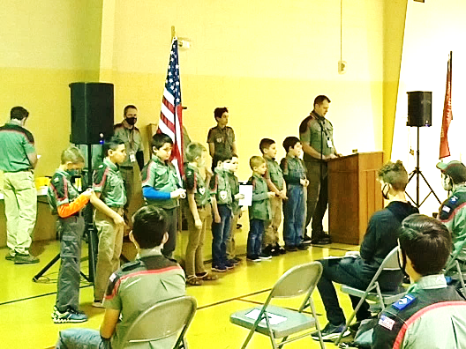
Trail Life had its Court of Honor and Advancement Ceremony Awards this past Tuesday, December 15.
Trail Life, Troop 412 meets Tuesday at 7:00 PM in the GYM. Open to boys ages 5-17. For information see Pastor Bruce. The next meeting is January 5.

Pray for our Missionaries - Joe and Ann Lyle, Taiwan
First, thank you so much for your prayers. We have seen some
answers.

Request from our last email: Pray for Joe and I (and the other teachers). We are only into week 5 and we are tired. ….
Answer: Still taking one day at a time…. Sunday night, we tried to Zoom with the Nam family (Our new MTW missionaries). Never could get it to work right and ended up using a cell phone and an iPad. Everyone was trying to help and we ended up laughing through most of our time… We definitely need to laugh more.

Request from our last email: Pray that the college would see the need for an administrative assistant in the English Major. I (Ann) love this work, but need to pass it on to spend more time with students in need.
Answer: Nothing on the administrative assistant yet. However, I was able to give over the planning for the faculty and staff Thanksgiving potluck dinner this year. Some great people will be doing it. Continue to pray for the administrative assistant need and that I will find ways to pass on responsibilities to others.
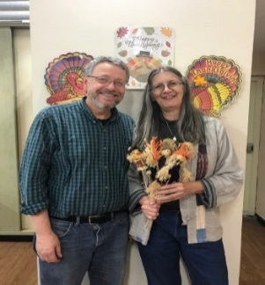
As you pray for us, please know we are praying for your safety and for God’s present help in this time.
God is our refuge and strength, a very present help in trouble. Psalm 46:1 Joe and Ann Lyle

Church Calendar
Worship Service Dec. 20 Sunday at 10:00 AM
Christmas Eve Service December 24 5:00 PM
Trail Life Tuesday, Jan. 5, 7:00 PM Meeting in the GYM
Wed. Night Bible Study Jan. 6, 7:00 PM

Church Families for Prayer
Sunday, Dec. 20 Danny and Vicki Robbins
Monday, Dec. 21 Sandy Smith
Tuesday, Dec. 22 Joe Strube
Wednesday, Dec. 23 Bernard and Jean Tilanus
Thursday, Dec. 24 Betty Wallace
Friday, Dec. 25 Johnny and Shelby Wallace
Saturday, Dec. 26 Bruce and Lydia Watson
Congregational Meeting
Prosperity’s Yearly Congregational Meeting will be Sunday, January 31, 2021 immediately following the 10:00 AM Worship Service. Please plan to attend.
Member Directories, Treasurers Reports and Bulletins from past Sundays are in the rack in the office hallway; you may wish to take one home. Pictures from the Christmas Child Packing Center, and pictures of Trail Life are on the board. Other flyers are also there.
Nominations for Elder and Deacon
The Session announces the opening of nominations for elder and deacon. Before nominating an individual please review the qualifications for these offices in I Timothy 3:1-13. Also please check with the person you are nominating to ensure they are willing to serve. Fill in the nomination form and give to an elder, or put in the offering plate or send to the church office. Forms are due by Sunday, January 24, 2021.

Believing that _____________________________________________meets the qualification of scripture, I nominate him for the office of elder _______________________ or deacon __________________________.

Signature____________________________________________________

Date ___________________________

Sunday Morning Worship Service
Prosperity’s online Worship Service is available, and is posted on our Facebook Page - Prosperity Presbyterian Church at 10 AM. If you would like to view the service through our website check out https://www.prosperitypca.com/worship-services or listen to the sermon audio at LORD and Promise — Prosperity PCA

Wednesday Night Bible Study
The next Wednesday Night Bible Study is scheduled for January 6, 2021 at 7:00 PM. We will meet in the sanctuary or you may continue to participate on Zoom.
Below is a link to our Bible study on Zoom.
Call in Wednesday, Jan. 6 around 6:55.
The number is (408) 638-0968.
Once you place your call you will be asked to enter the meeting ID#. The ID# is 220 654 4063. After entering the ID# You will be asked to enter a participant ID, just skip this step by pressing the # button.
You can also join this meeting using your computer to join Zoom Meeting – via an Electronic Device (computer)
The link is https://us02web.zoom.us/j/2206544063. The ID is 220 654 4063.

