**Church Directory**

##### Staff

##### Pastor Rev. Bruce Brown

Office Administrator Dot Snyder

Preschool Director Isabelle Dontsop

Church Treasurer Earl Dove

Music Coordinator Brian Dove

Flower Coordinator Isabelle Dontsop

Prayer Chain Coordinator Brenda Anderson

###### Ruling Elders

Fred Entrekin 3/21 Elder

T. R. Hunter 3/21 Session Clerk

Joe Strube Elder Emeritus

**Deacons**

Earl Dove 10/23 Finance

Nelson Jenkins 3/21 Mercy

Johnny Wallace 3/21 Property

Raymond Wilson 3/21 Ushers, Property

**Missionaries**

Joe and Ann Lyle - MTW Taiwan

Larry and Sandra Rockwell–MTW Peru

Bill and Susan Carr – MTW Sioux Indians, MN

Michael and Lindie Wadhams-MTW Lummi Indians, WA

**Need to Reach Us?**

Rev. Bruce Brown ………………….………. [christshousehold@yahoo.com](mailto:christshousehold@yahoo.com)

[704-698-8009](tel:704-698-8009) cell

704-875-1182 ext. 6 church

Preschool….………………………..………….. Isabelle Dontsop - 704-947-0228

Dontsop cell 980-248-9306

E-mail……………………….…............ director@prosperitypreschool.com

Church Office…………………..…………..… 704-875-1182 Ext. 4

E-mail……………..…………..…………. [email@prosperitychurch.org](mailto:email@prosperitychurch.org)

Website…………………………………………. [WWW.prosperitypca.com](http://WWW.prosperitypca.com)

Church Office Hours………..………..…... Tues.-Fri. 8:00 AM-12:30 PM

Prayer Chain Coordinator………………..Brenda Anderson

704-875-2351 - [brendaea42@gmail.com](mailto:brendaea42@gmail.com)

**Welcome to Prosperity Church Service!**

We warmly welcome you to the Prosperity Church Worship Service. We are honored to share this morning service with you as we worship God's risen Son. May you know the love of God and feel His presence, for you are special to the Lord, and to us. We pray that God will touch your life during the service, and that you will know His peace.

**Welcome Jay and Wendy Krestar**

Jay Krestar is from Concord, North Carolina.  He is a Ruling Elder at Grace Church Harrisburg, PCA and serves as the Clerk of Session and teaches Adult Sunday School on a regular basis.

Jay has been married for 31 years to his lovely wife, Wendy and they have two children.

Their daughter, Emily, is married to Austin Madison and is living in Hickory NC and teaching music.  Their son, Ethan, is a senior at Central Cabarrus High-school.

Jay is a Respiratory Therapist by profession and is currently pursuing his Masters of Divinity through LAMP seminary in Charlotte.

Wendy and Jay would like to thank the Prosperity Congregation for inviting them to worship with you this morning.

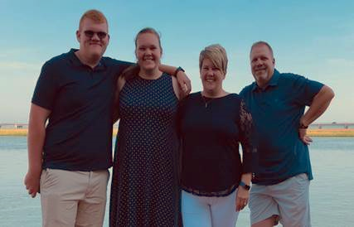

**Announcements**

**Sunday Morning Worship Service**

Prosperity’s online Worship Service is available, and is posted on our [**Facebook Page - Prosperity Presbyterian Church**](https://www.facebook.com/Prosperity-Presbyterian-Church-275363616175410/) at 10 AM.  If you would like to view the service through our website check out <https://www.prosperitypca.com/worship-services>  or listen to the sermon audio at **Inexpressible Joy**[**—Prosperity PCA**](https://www.prosperitypca.com/from-the-pulpit)

**Wednesday Night Bible Study**

**The next Wednesday Night Bible Study is scheduled for January 6, 2021 at 7:00 PM. We will meet in the sanctuary or you may continue to participate on Zoom.**

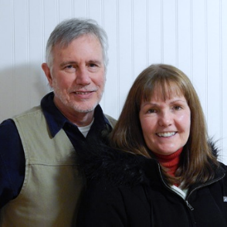

**Pray for our Missionaries**

**Bill and Susan Carr, Sioux Indians, MN**

**We thank the Lord for the success of the Native America Pastors’ Gathering. May it further build and strengthen bridges with our Native Americans and First Nations brethren.**

**Pray for Susan as she teaches. The paperwork is overwhelming, making it difficult to teach. She is working very hard to keep students motivated. Pray that God will give her energy and encouragement.**

**Pray for Bill, that God will give him wisdom, strength, and faithfulness as he ministers to and with all phases of indigenous NA Ministries.**

**Hopefully, by the end of December/early January, we will have another church planting family on their field. DH and Emily Henry are planning to work with Navajo after relocating to Flagstaff, AZ. They are currently at 75 percent of their support.**

**Because of border restraints, our MTW missionaries and affiliates in Canada really cannot come across to the US and expect to return, nor can we go to them.**

**Susan and I have so much to be thankful for … every day. We are particularly thankful for your partnership in the Gospel with us. Your prayers and support help us to stay the course. May the Lord bless you all. *Bill And Susan.***

**Church Calendar**

**Worship Service Dec. 27 Sunday at 10:00 AM**

**Trail Life Tuesday, Jan. 5, 7:00 PM Meeting in the GYM**

**Wed. Night Bible Study Jan. 6, 7:00 PM**

**Communion Jan. 10**

**Congregational Meeting Jan. 31 After Service**

**Church Families for Prayer**

**Sunday, Dec. 27 Gwen Whitley**

**Monday, Dec. 28 Raymond and Myra Wilson**

**Tuesday, Dec. 29 Richard Altork**

**Wednesday, Dec. 30 Jim and Brenda Anderson**

**Thursday, Dec. 31 Bill and Patsy Barnett**

**Friday, Jan. 1 Wally Barnett**

**Saturday, Jan. 2 Victor and Helen Bedu**

**Communion**

We will observe **Communion** Sunday, January 10, 2021.

**Congregational Meeting**

**Prosperity’s Yearly Congregational Meeting** **will be Sunday, January 31, 2021** immediately following the 10:00 AM Worship Service. Please come to the Worship Service and remain for the meeting.

**January 3, 2021 is Deacon’s fund Sunday.**

**Nominations for Elder and Deacon**

The Session announces the opening of nominations for elder and deacon. **Before nominating an individual please review the qualifications for these offices in I Timothy 3:1-13. Also please check with the person you are nominating to ensure they are willing to serve.** Fill in the nomination form and give to an elder, or put in the offering plate or send to the church office. **Forms are due by Sunday, January 24, 2021.**

Believing that_____________________________________________________ meets the qualification of scripture, I nominate him for the office of elder _______________________ or deacon __________________________.

Signature____________________________________________________

Date _______________________________________________________