**Church Directory**

##### Staff

##### Pastor Rev. Bruce Brown

Office Administrator Dot Snyder

Preschool Director Isabelle Dontsop

Church Treasurer Earl Dove

Music Coordinator Brian Dove

Flower Coordinator Isabelle Dontsop

Prayer Chain Coordinator Brenda Anderson

###### Ruling Elders

Fred Entrekin 3/21 Elder

T. R. Hunter 3/21 Session Clerk

Joe Strube Elder Emeritus

**Deacons**

Earl Dove 10/23 Finance

Nelson Jenkins 3/21 Mercy

Johnny Wallace 3/21 Property

Raymond Wilson 3/21 Ushers, Property

**Missionaries**

Joe and Ann Lyle - MTW Taiwan

Larry and Sandra Rockwell–MTW Peru

Bill and Susan Carr – MTW Sioux Indians, MN

Michael and Lindie Wadhams-MTW Lummi Indians, WA

**Need to Reach Us?**

Rev. Bruce Brown ………………….………. [christshousehold@yahoo.com](mailto:christshousehold@yahoo.com)

[704-698-8009](tel:704-698-8009) cell

704-875-1182 ext. 6 church

Preschool….………………………..………….. Isabelle Dontsop - 704-947-0228

Dontsop cell 980-248-9306

E-mail……………………….…............ director@prosperitypreschool.com

Church Office…………………..…………..… 704-875-1182 Ext. 4

E-mail……………..…………..…………. [email@prosperitychurch.org](mailto:email@prosperitychurch.org)

Website…………………………………………. [WWW.prosperitypca.com](http://WWW.prosperitypca.com)

Church Office Hours………..………..…... Tues.-Fri. 8:00 AM-12:30 PM

Prayer Chain Coordinator………………..Brenda Anderson

704-875-2351 - [brendaea42@gmail.com](mailto:brendaea42@gmail.com)

**Welcome to Prosperity Church Service!**

We warmly welcome you to the Prosperity Church Worship Service. We are honored to share this morning service with you as we worship God's risen Son. May you know the love of God and feel His presence, for you are special to the Lord, and to us. We pray that God will touch your life during the service, and that you will know His peace.

 **Christmas Eve Candlelight Worship Service**

**Thursday, December 24, 5:00 PM**

**Christmas Hymns, Scripture Readings**

**Lighting the White Advent Candle**

**Lighting the Congregational Candles**

**Christmas Message from Pastor Bruce**

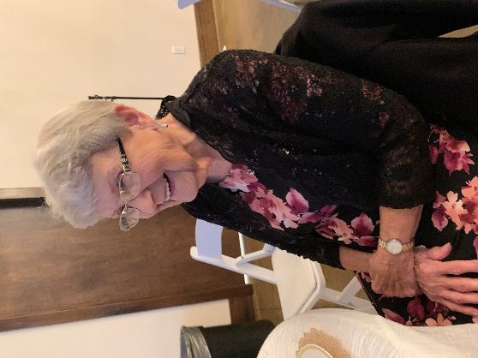

**Happy Birthday**

**Betty Wallace**

***The Wallace and Billings***

***Families wish Betty Wallace***

***a Happy***

***92nd Birthday.***

 **Announcements**

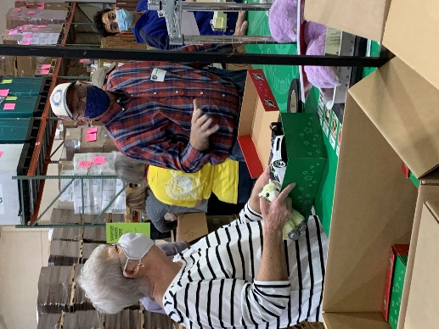**Operation Christmas Child –** Thank you for the shoeboxes you prepared for Operation Christmas Child. **We had 81 boxes this year; this is a tremendous number of boxes given by the Prosperity Congregation, Preschool and Trail Life.** You are sharing the love of Jesus through the power of a simple gift with the children around the world. Pray for the children who receive the boxes that they will come to know Christ as their personal savior, and then share His good news with their friends. (The picture is at the Packing Center, 6 people from Prosperity helped pack.)

**Deacon’s Fund**

The first Sunday of each month has been designated as **Deacon’s Fund Sunday.** Please make this contribution above your regular offering. **Put your check in a separate envelope and mark it for the Deacon’s Fund, and place it in the silver offering plate at the left back door.**

**Pray for our Missionaries - Larry and Sandy Rockwell - Peru**

On Larry’s last trip, he met daily with an 18 year old young man whose name is Robinson. Larry was walking by as Robinson and his family were working in their field harvesting potatoes. They called out to Larry to come and have some potatoes they had just harvested and boiled right there in the field. While they were eating, Robinson expressed his desire to learn English and asked Larry if he would be willing to teach him. Larry agreed and each day they would meet for almost two hours. Larry used a booklet called *Ultimate Questions* to teach him English, but also share the gospel with him which raises questions about whether God exists, who He is, etc.

Robinson loves to read and is very interested in learning. During one of their times together the issue of Mary being able to save people came up. Larry shared what the Bible says about Mary being a sinner like all of us, and encouraged Robinson to research this for himself. When he came back the next day he told Larry that it was true that Mary was a sinner and not able to save anyone.

These are just a very small representation of the people that Larry has been able to encourage with the gospel thanks to all of you.

Serving together with you by His grace, *Larry and Sandy Rockwell*

**Trail Life, Troop 412 meets Tuesday at 7:00 PM in the GYM.** Open to boys ages 5-17. For information see Pastor Bruce.

**Church Calendar**

**Worship Service Dec. 6 Sunday at 10:00 AM**

**Deacon Fund Sunday Dec. 6**

**Session Meeting Dec. 6 Sunday at 6:00 PM**

**Trail Life Tuesday, Dec. 8, 7:00 PM Meeting in the GYM**

**Wed. Night Bible Study Dec. 9, 7:00 PM**

**American Red Cross Blood Drive Dec. 11 Friday 10 AM to 2:30 PM**

**Christmas Eve Service December 24 5:00 PM**

**Church Families for Prayer**

**Sunday, Dec. 6 Armando and Eunice Hernandez**

**Monday, Dec. 7 T. R. and Alma Hunter**

**Tuesday, Dec. 8 Nelson and Patty Jenkins**

**Wednesday, Dec. 9 Gypsy Keith**

**Thursday, Dec. 10 Bob Kidder**

**Friday, Dec. 11 Nancy Lindley**

**Saturday, Dec. 12 Gerald and Argie Locklear**

**The Red Cross will be at Prosperity Church Friday, December 11, 10:00 AM to 2:30 PM The trucks will be parked beside the GYM. Donors need to schedule by calling 1-800-733-2767.**

**In November Prosperity Church Hosted the American Red Cross Blood Drive; 23 People Gave Blood. This has the potential for Helping 69 People!**

**Welcome Visitors**

**You are welcome to our service today and we would like to get to know you. All visitors please fill out this form, tear it from the bulletin and place in the offering plate or give to an usher.**

**Visitor’s Name _____________________________________________**

**Address __________________________________________________**

**Phone ____________________________________________________**

**Email _____________________________________________________**

**Please let us know if you have a prayer request or would like a visit from the pastor.**

**Other needs:**

**Sunday Morning Worship Service**

Prosperity’s online Worship Service is available, and is posted on our [**Facebook Page - Prosperity Presbyterian Church**](https://www.facebook.com/Prosperity-Presbyterian-Church-275363616175410/) at 10 AM.  If you would like to view the service through our website check out <https://www.prosperitypca.com/worship-services>  or listen to the sermon audio at **The Delightful Danger of Drawing Near** [**— Prosperity PCA**](https://www.prosperitypca.com/from-the-pulpit)

**Wednesday Night Bible Study**

**The next Wednesday Night Bible Study is scheduled for December 9 at 7:00 PM. Our lesson will be in chapters 1-2 (pages 155-162). The topic is *“When and How You Pray.”* We will meet in the sanctuary or you may continue to participate on Zoom.**

Our study book is on the **Apostle's Creed,** the **Lord’s Prayer** and the **10 Commandments.** The book is entitled **"Growing in Christ"** by J. I. Packer.

**Below is a link to our Bible study on Zoom.**

Call in Wednesday, Dec. 9 around 6:55.

The number is (**408) 638-0968**.

Once you place your call you will be asked to enter the meeting ID#. The ID# is 220 654 4063**.** After entering the ID# You will be asked to enter a participant ID, just skip this step by pressing the # button.

You can also join this meeting using your computer to join **Zoom** Meeting – via an Electronic Device (computer)

The link is [**https://us02web.zoom.us/j/2206544063**](https://us02web.zoom.us/j/2206544063)**.** The ID is 220 654 4063.