Church Directory

Staff

Pastor Rev. Bruce Brown
Office Administrator Dot Snyder
Preschool Director Isabelle Dontsop
Church Treasurer Earl Dove
Music Coordinator Brian Dove
Flower Coordinator Isabelle Dontsop
Ruling Elders
Fred Entrekin 3/24 Elder
Brian Dove 9/24 Elder – Session Clerk
T. R. Hunter Inactive
Joe Strube Elder Emeritus
Deacons
Earl Dove 10/23 Finance
Johnny Wallace 3/24 Property
Raymond Wilson 3/24 Ushers, Property
Ron Richmond 9/24 Mercy
Missionaries
Larry and Sandra Rockwell–MTW Huaraz, Peru
Bill and Susan Carr – MTW Sioux Indians, MN
Michael and Lindie Wadhams-MTW Lummi Indians, WA
Shaun and Becky Hurrie – MTW South Africa
Frank and Sheree Newell – MTW Middle East
Will and Martha Faires – Myanmar, Burma - Equipping Leaders
Andrew Goyzueta – RUF Davidson College

Need to Reach Us?

Rev. Bruce Brown ………………………… christshousehold@yahoo.com

704-698-8009 cell

704-875-1182 ext. 6 church
Isabelle cell 980-248-9306
E-mail……………………….….................. director@prosperitypreschoChurch Office…………………..……………………..… 704-875-1182 Ext. 4
E-mail……………..…………..…………..…… email@prosperitychurch.org
Website………………………………………… WWW.prosperitypca.com

Church Office Hours………..………..…. Tues.-Fri. 8:00 AM-12:30 PM

Welcome to Prosperity Church Service!

We warmly welcome you to the Prosperity Church Worship Service. We are honored to share this morning service with you as we worship God's risen Son. May you know the love of God and feel His presence, for you are special to the Lord, and to us. We pray that God will touch your life during the service, and that you will know His peace.

Sunday School

We have a class for everyone. Come to Sunday School at 8:55 AM.

Opening Assembly
Beginning August 7 - we will meet each week in the Sanctuary for Opening Assembly at 8:55 AM. Then we will go to our Sunday School Classes at 9:05 AM.

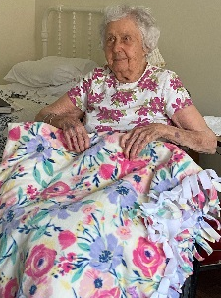
Thank you
Josie Barbee was so happy to receive her beautiful blanket and said thank you to the Women's Ministry.
She referred to it as “gorgeous” and a “master piece.” She wanted the ladies to know they did beautiful work and she loves her “blanket of blessings.”
(Myra and Lucy)

Announcements

Officer’s Training Class
Our next meeting will be Wednesday, August 3,
at 6:00PM in the pastor's study.

Deacon’s Fund Sunday, August 7. The first Sunday of each month has been designated as the Deacon’s Fund Sunday. Please mark your check for the Deacon’s Fund and place it in the plate as it is passed around.

The May and June Treasurers’ Reports are available in the narthex and the office hallway.

Trail Life, Our younger Trailmen (5-10) are taking a break over the summer. The Navigators and Adventurers (11-17) continue to meet each Tuesday at 7:00PM in the Gym
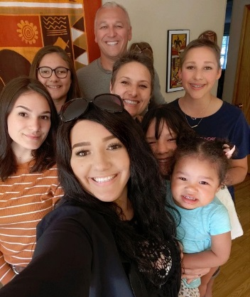
Pray for Our Missionaries
Michael and Lindie Wadhams
Lummi Indians, WA

Michael and Lindie Wadhams, along with their daughters Sabrina, Eden, Emma, Kimberly, and Michaela, serve with MTW to continue the work that MTW teams began on the Lummi Indian Reservation.

This year we have been busy with mission conferences and have had the opportunity to preach in South Carolina. In April we were in San Diego to highlight native ministry at the Witness Conference. It has been two years since we last had teams participate due to the pandemic. We were informed that should we get the approval; we will be limited on our team numbers. Hopefully we can accommodate teams at other venues to meet the needs of the tribes.

In October we will be participating in our yearly Native Pastors’ Gathering and this year our goal is to take a native candidate from Nooksack! On the heels of the pastors’ Conference, we will be in Phoenix speaking at the Equip Conference, to raise awareness of urban native ministry, and hope to recruit future missionaries from our western states.
Thank you for your prayers and support. Michael and Lindie.

Church Calendar
July 31, Sun. Worship Service 10:00 AM
July 31, Sun. Sunday School Kick Off 9 AM
Aug 2, Tue. Trail Life 7:00 PM
Aug 3, Wed. Officer’s Training Class 6 PM

Church Families for Prayer
Sunday, July 31 Inez Brown
Monday, Aug. 1 Pastor Bruce Brown and Family
Tuesday, Aug. 2 John and Nicole Chiulli Family
Wednesday, Aug. 3 Olivia Clark
Thursday, Aug. 4 Jackie Clark
Friday, Aug. 5 Carol Comer
Saturday, Aug. 6 Janice Connell

* Brenda Myers We thank everyone for their prayers, cards, calls and help during Brenda’s illness. Thank you for all your support. Brenda is able to walk and drive her car and leave home and enjoy her life now. She is a walking miracle.
* Please pray for Peter Ellsworth as he awaits an upcoming procedure to increase blood flow in a pulmonary artery.

* Bernard Tilanus needs prayer for his eyes. He has macular degenerative disease and glaucoma. His one eye is no longer responding to treatment and he will probably need to have surgery. He has to drive to Lincolnton five days a week for his employment. We are praying Aspen Dental transfers him to an office close to his home and that the doctors are wise in their eye treatment.

* Cathee Griffin - Please pray for Cathee. She needs our prayers.
* Brenda Anderson. Please pray for Brenda that the doctors will find a cure for her.

* Josie Barbee is feeling much better, and has moved to an assisted living center, Ranson Ridge Assisted Living, 13910 Hunton Lane, Huntersville, NC 28078, 704-897-2723. She asks that everyone continue to pray for her.
* JoAnne Perry is now at home (10001 John Adams Road, Charlotte, NC 28262). Pray for God's strength for JoAnne and granddaughter Melanie.

Online Worship Service
Prosperity’s online Worship Service is available, and is on our Facebook Page - Prosperity Presbyterian Church at 10 AM. To view the service through our website check out https://www.prosperitypca.com/worship-services or listen to the sermon audio at “A Faith of Equal Standing” Prosperity PCA

