**Church Directory**

##### Staff

##### Pastor Rev. Bruce Brown

Office Administrator Dot Snyder

Preschool Director Isabelle Dontsop

Church Treasurer Earl Dove

Music Coordinator Brian Dove

Flower Coordinator Isabelle Dontsop

**Ruling Elders**

Fred Entrekin 3/24 Elder

Brian Dove 9/24 Elder – Session Clerk

T. R. Hunter Inactive

Joe Strube Elder Emeritus

**Deacons**

Earl Dove 10/23 Finance

Johnny Wallace 3/24 Property

Raymond Wilson 3/24 Ushers, Property

Ron Richmond 9/24 Mercy

**Missionaries**

Larry and Sandra Rockwell–MTW Huaraz, Peru

Bill and Susan Carr – MTW Sioux Indians, MN

Michael and Lindie Wadhams-MTW Lummi Indians, WA

Shaun and Becky Hurrie – MTW South Africa

Frank and Sheree Newell – MTW Middle East

Will and Martha Faires – Myanmar Equipping Leaders

Andrew Goyzueta – RUF Davidson College

**Need to Reach Us?**

Rev. Bruce Brown ………………………… [christshousehold@yahoo.com](mailto:christshousehold@yahoo.com)

[704-698-8009](tel:704-698-8009) cell

704-875-1182 ext. 6 church

Dontsop cell 980-248-9306

E-mail……………………….….................. director@prosperitypreschoChurch Office…………………..……………………..… 704-875-1182 Ext. 4

E-mail……………..…………..…………..…… [email@prosperitychurch.org](mailto:email@prosperitychurch.org)

Website………………………………………… [WWW.prosperitypca.com](http://WWW.prosperitypca.com)

Church Office Hours………..………..…. Tues.-Fri. 8:00 AM-12:30 PM

Prayer Chain Coordinator……….……… Brenda Anderson 704-875-2351

**Welcome to Prosperity Church Service!**

**We warmly welcome you to the Prosperity Church Worship Service. We are honored to share this morning service with you as we worship God's risen Son. May you know the love of God and feel His presence, for you are special to the Lord, and to us. We pray that God will touch your life during the service, and that you will know** **His peace.**

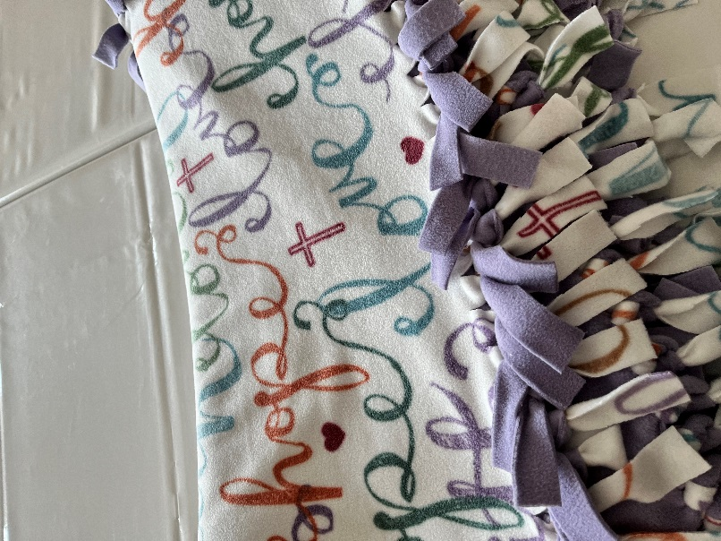

**Love and Blessings Blankets**

**Tuesday, June 21 at 6 PM,**

**at Betty Wallace’s home (14324 Eastfield Road).**

**Myra will demonstrate how to make a blanket (no sew) and everyone will help complete it.**

**If time allows, we can make the second blanket. Myra will have a written handout to give to you to take home with all instructions.**

**Please call ASAP Lucy (704) 345-2250 and let her know you are coming**.

**Inquirer’s Class**

**This class is taught by Pastor Bruce each Sunday at 9:00 AM in the sanctuary.**

**There is still time to attend, if you are interested in becoming a member, or just wish to learn more about Prosperity Presbyterian Church, please let Pastor Bruce know.**

**The Officer’s Training Class meets each**

**Wednesday at 7:00 PM in the sanctuary.**

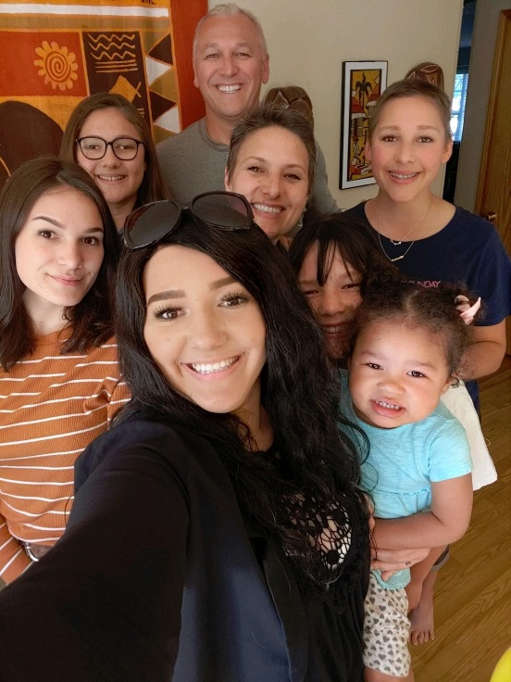

**Pray for Our Missionaries**

**Michael and Lindie Wadhams**

**Lummi Indians, WA**

The Wadhams reside in Lynden, Washington, which is nestled between the Nooksack and Lummi reservations. They labor among the tribes through developing relations, evangelism, and mentoring/discipleship. The long-term goal is to establish Native churches in the region. **The Wadhams Family**

Our recent ministry was hosting our 2nd annual *Pastors Gathering* in Florence MS. The theme was “*The Kingdom Come: Awaiting the King in a Fallen World.”* It was attended by pastors and their wives from various tribes (Kiowa/Mohawk, Blackfeet, Navajo, Hopi, Cree, Lakota/Seminole and Ojibwa).

This was a fruitful time where relationships were forged and deepened, and native pastors were strengthened and equipped to continue their ministries. The eagerness these men, with their wives, exhibited was astounding to say the least, considering that many are going into areas of extreme poverty, substance abuse, and spiritual adversity.

In Canada from Lethbridge to Maskwacis, Alberta to Moose Factory, Ontario down to Cherokee, NC and Florida, and to Flag Staff Arizona amongst the Navajo up to the Pacific Northwest, our region has missionaries faithfully serving the indigenous tribes. We are only touching the tip of the proverbial iceberg, and the opportunities and needs are vast as we seek to serve and expand our native region. ***Michael and Lindie Wadhams***

**Church Calendar**

**June 12, Sun. Worship Service 10:00 AM**

**June 12, Sun. Inquirer’s Class 9:00 AM**

**June 14, Tue. Trail Life 7:00 PM**

**June 15, Wed. Officer’s Training Class 7:00 PM**

**June 21, Tue. Women Meet at Betty Wallace’s home**

**Church Families for Prayer**

**Sunday, June 12 Carolyn Davis**

**Monday, June 13 Isabelle Dontsop Family**

**Tuesday, June 14 Earl and Polly Dove**

**Wednesday, June 15 Brian Dove Family**

**Thursday, June 16 Caleb Eldridge Family**

**Friday, June 17 Tom Ellsworth Family**

**Saturday, June 18 Fred Entrekin**

**Pollyanna** (Secret Sisters) The church women will begin this project in July. **Please let Lucy know if you are interested. (704) 345-2250.**

**\* Brenda Anderson** has been sick for several weeks. Please pray the doctors will find the cause and she will soon be well.Please continue praying for Brenda.

**\* Josie Barbee** is feeling much better, and has moved to an assisted living center, Ranson Ridge Assisted Living, 13910 Hunton Lane, Huntersville, NC 28078, 704-897-2723. She asks that everyone continue to pray for her.

**\* Brenda Myers** has improved and is now at home. She is not walking very well and must use a walker. Her daughter, Karen, and Polly Dove are taking care of her.

**\* JoAnne Perry** is now at home (10001 John Adams Road, Charlotte, NC 28262). Pray for God's strength for JoAnne and granddaughter Melanie.

**Trail Life,** meets each Tuesday at 7:00 PM in the Gym. Open to boys ages 5-17. For information see Pastor Bruce.

**Online Worship Service**

**Prosperity’s online Worship Service** is available, and is on our **Facebook Page - Prosperity Presbyterian Church** at 10 AM. To view the service through our website check out <https://www.prosperitypca.com/worship-services>  or listen to the sermon audio at **“A Planned Defeat”**[**Prosperity PCA**](https://www.prosperitypca.com/from-the-pulpit)

Please pray for the people in **Ukraine.**