**Church Directory**

##### Staff

##### Pastor Rev. Bruce Brown

Office Administrator Dot Snyder

Preschool Director Isabelle Dontsop

Church Treasurer Earl Dove

Music Coordinator Brian Dove

Flower Coordinator Isabelle Dontsop

Prayer Chain Coordinator Brenda Anderson

###### Ruling Elders

Fred Entrekin 3/24 Elder

T. R. Hunter Inactive

Joe Strube Elder Emeritus

**Deacons**

Earl Dove 10/23 Finance

Johnny Wallace 3/24 Property

Raymond Wilson 3/24 Ushers, Property

**Missionaries**

Joe and Ann Lyle - MTW Taiwan

Larry and Sandra Rockwell–MTW Peru

Bill and Susan Carr – MTW Sioux Indians, MN

Michael and Lindie Wadhams-MTW Lummi Indians, WA

Shaun and Becky Hurrie – MTW South Africa

**Need to Reach Us?**

Rev. Bruce Brown ………………….………. [christshousehold@yahoo.com](mailto:christshousehold@yahoo.com)

[704-698-8009](tel:704-698-8009) cell

704-875-1182 ext. 6 church

Preschool….………………………..………….. Isabelle Dontsop - 704-947-0228

Dontsop cell 980-248-9306

E-mail……………………….…............ director@prosperitypreschool.com

Church Office…………………..…………..… 704-875-1182 Ext. 4

E-mail……………..…………..…………. [email@prosperitychurch.org](mailto:email@prosperitychurch.org)

Website…………………………………………. [WWW.prosperitypca.com](http://WWW.prosperitypca.com)

Church Office Hours………..………..…... Tues.-Fri. 8:00 AM-12:30 PM

Prayer Chain Coordinator………………..Brenda Anderson

704-875-2351 - [brendaea42@gmail.com](mailto:brendaea42@gmail.com)

**Welcome to Prosperity Church Service!**

**We warmly welcome you to the Prosperity Church Worship Service. We are honored to share this morning service with you as we worship God's risen Son. May you know the love of God and feel His presence, for you are special to the Lord, and to us. We pray that God will touch your life during the service, and that you will know** **His peace.**



**Presbyterian Church in America**

**48th General Assembly**

**June 28-July 2, 2021**

**America’s Convention Center**

**St. Louis, Missouri**

***Please pray for Pastor Bruce while he is away, ask God to keep him safe.***

***Also, pray for the decisions made during the Assembly meetings.***

**Church Calendar**

**June 27, Sunday Sunday School 9:00 AM**

**June 27, Sunday Worship Service at 10:00 AM**

**June 29, Tuesday Trail Life 7:00 PM**

**June 30, Wednesday 7:00 PM Bible Study – Daniel**

**July 11, Sunday Communion**

**Wednesday Night Bible Study**

**June 30, at 7:00 PM. Our Wed. Bible Study is DanieL**

**We meet in the sanctuary.**

**Here is a link to our Bible Study on Zoom.**

Call in Wednesday around 6:55. The number is (**408) 638-0968**.  Once you place your call you will be asked to enter the meeting ID#. The ID# is 220 654 4063**.** You will be asked to enter a participant ID, just skip this step by pressing the # button. You can also join this meeting using your computer to join **Zoom** Meeting – via an Electronic Device (computer)

The link is [**https://us02web.zoom.us/j/2206544063**](https://us02web.zoom.us/j/2206544063)**.** The ID is 220 654 4063.

**Prosperity’s online Worship Service** is available, and is on our **Facebook Page - Prosperity Presbyterian Church** at 10 AM. To view the service through our website check out <https://www.prosperitypca.com/worship-services>  or listen sermon audio at ***“Sin and Power”*** [**- Prosperity PCA**](https://www.prosperitypca.com/from-the-pulpit)

**Sunday School 9 AM**

**Sunday School will run through this**

**Sunday, June 27th.**

**Beginning July 4th we will take a**

**summer break and will pick back up Sunday, September 12th, 2021.**

* **Remember the Carpet Fund. We now have $14,130.00.** If you would like to give, make your check to the **Carpet Fund** and place it in the plate at the back of the church.
* **Communion - We will observe Communion July 11.**
* **Trail Life - Troop 412 meets each Tuesday at 7:00 PM in the GYM.**
* **Officer’s Meeting today at 6:00 PM in the library.**

**Church Families for Prayer**

**Sunday, June 27 Joanne Perry**

**Monday, June 28 Ron and Lucy Richmond**

**Tuesday, June 29 Danny and Vicki Robbins**

**Wednesday, June 30 Sandy Smith**

**Thursday, July 1 Joe Strube**

**Friday, July 2 Bernard and Jean Tilanus**

**Saturday, July 3 Betty Wallace**

**Pray for our Missionaries**

**Shaun, Becky Hurrie and Family – South Africa**

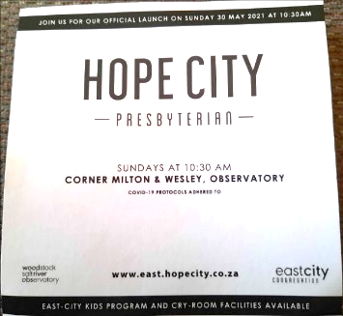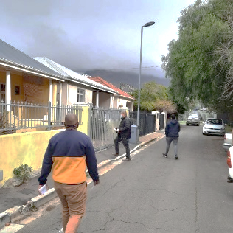

On the left Pastor Stephen Murray of the Hope City Pres. – City Bowl congregation, as well as international partners sharing words of encouragement on Launch day. On the right is Pastor Wesley Marshall of Hope City Pres. East City Congregation.

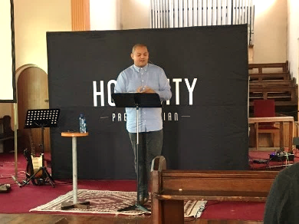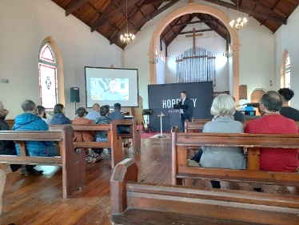

**Pictures of South Africa sent by Shaun Hurrie.**



Hello dear partners in Christ,

“We’d like to begin this letter by saying thank you for your prayers last month as we were searching for a vehicle and home. We have found both and look forward to moving into our own place during the month of June. We truly appreciate your prayers on our behalf.

**Launch** - On Sunday, May 30th the Hope City Presbyterian Church – East City Congregation had their first official launch service. This is a huge praise! After 4 years of praying, planning, and a year of dealing with the reality of lock-downs and waves of Covid infections, the Lord has granted this local body its paticular status. The East City represents the areas of Observatory, Salt River and Woodstock (east of the city bowl of Cape Town). Shaun had the opportunity to join with the pastors and another congregants in passing out flyers door-to-door the week prior to the Launch to invite people in the Observatory community to come visit the new church plant. We are unsure as to the exact number who responded to the flyer (often left on their front gate since many weren’t home). We did get to speak to two of them; they were a delightful pair to chat with, and we are hopeful we will see them again. It is you, our prayer and support partners, who make this Gospel reach possible.

**Level 2 Lockdown** – presently, certain provinces within South Africa have reached a third wave of Covid-19. It is expected to hit all of the provinces, so they have implemented Level 2 Lockdown. This means continuing of mask wearing, social distancing, and restricting numbers at gatherings.

The vaccine rollout has begun here, with ages 60 and above, as well as health care workers currently first. This may sound surprising since we know many states in the US have dropped their mask mandates etc. so, please do remember this country in your prayers as we enter the winter months of June-August. This new wave can have a HUGE impact on people in need. Almost daily, we have someone ring our gate bell asking for food or warmer clothers. We do what we can and offer sandwiches and the occasional hot coffee. Even more acute unemployment is a concern especially during these times. Please pray that we would be able to provide not only physical bread, but we can share about the true Bread of Life.

As mentioned in our previous update, we are continuing to get to know and build relationships with those whom we will be working directly alongside in ministry, as well as the network of people who are involved in Gospel ministry in Southern Africa. This process is and will prove vital for sustained ministry in a context of trust and mutual love. Along those lines, Shaun got to join in the bi-annual Southern Africa Reformed Mission (SARM) board meeting via ZOOM over the course of 2.5 hours each day this past Monday and Tuesday. This board (made up of National Partners/pastors, MTW missionaries, and Stateside PCA Pastors/mission’s directors) sets direction, finances, and planning for strategic church planting and similar reformed ventures across Sub-Saharan Africa. Please continue to lift this up before the throne of grace.

**The kids** have been doing well overall and are currently on a break from school. They have been enjoying various activities with their hiking group as well as making new friends at church. Please pray that the Lord would bring more kids their age to the church. They certainly miss friends and family in the states, but are settling in well. Thanks for your prayers for them.”

Much love in Christ, The Hurries

**Prayers and Praises**

**Praise** that we were able to find a vehicle and rental home!

**Pray** that the third wave of COVID will have minimum impact on the country.

**Pray** as we adjust to another new home location.

**Pray** specifically that God would bring more young kids into the church.

**Pray** that Shaun will be able to meet with the director of the Christian Leadership Program soon.