Church Directory

Staff

Pastor Rev. Bruce Brown
Office Administrator Dot Snyder
Preschool Director Isabelle Dontsop
Church Treasurer Earl Dove
Music Coordinator Brian Dove
Flower Coordinator Isabelle Dontsop
Ruling Elders
Fred Entrekin 3/24 Elder
Brian Dove 9/24 Elder – Session Clerk
T. R. Hunter Inactive
Joe Strube Elder Emeritus
Deacons
Earl Dove 10/23 Finance
Johnny Wallace 3/24 Property
Raymond Wilson 3/24 Ushers, Property
Ron Richmond 9/24 Mercy
Missionaries
Larry and Sandra Rockwell–MTW Huaraz, Peru
Bill and Susan Carr – MTW Sioux Indians, MN
Michael and Lindie Wadhams-MTW Lummi Indians, WA
Shaun and Becky Hurrie – MTW South Africa
Frank and Sheree Newell – MTW Middle East
Wil and Martha Faires - Myanmar
Andrew Goyzueta – RUF Davidson College

Need to Reach Us?

Rev. Bruce Brown ………………………… christshousehold@yahoo.com

704-698-8009 cell

704-875-1182 ext. 6 church
Dontsop cell 980-248-9306
E-mail……………………….….................. director@prosperitypreschoChurch Office…………………..……………………..… 704-875-1182 Ext. 4
E-mail……………..…………..…………..…… email@prosperitychurch.org
Website………………………………………… WWW.prosperitypca.com

Church Office Hours………..………..…. Tues.-Fri. 8:00 AM-12:30 PM
Prayer Chain Coordinator……….……… Brenda Anderson 704-875-2351

Welcome to Prosperity Church Service!

We warmly welcome you to the Prosperity Church Worship Service. We are honored to share this morning service with you as we worship God's risen Son. May you know the love of God and feel His presence, for you are special to the Lord, and to us. We pray that God will touch your life during the service, and that you will know His peace.

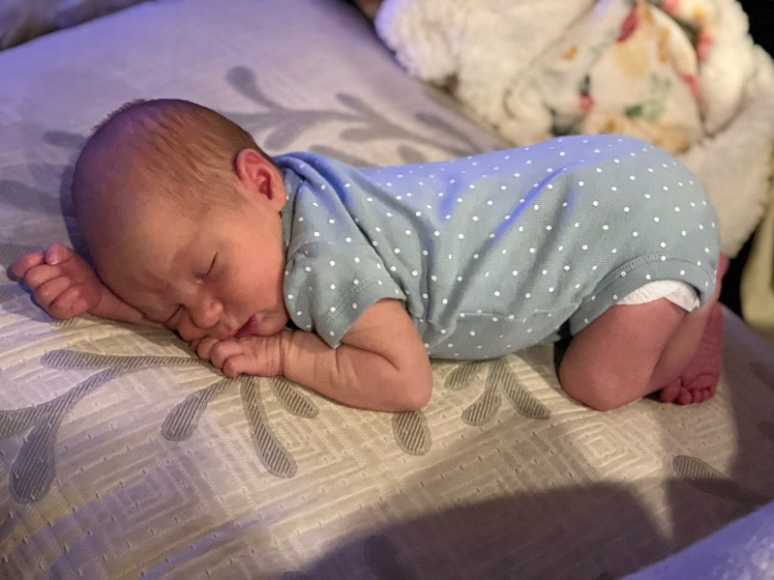
Avery Lou Gramm
Avery was born Thursday, May 26 at 9: 56 am. She was 7lbs 12 oz and 20.5 long.
Scott said, “Mom and baby are absolutely PERFECT! She couldn't be more happy and alert! To say we are in love would be a huge understatement. The last week has been a whirlwind and absolutely wonderful.
We will be back to Prosperity Church as soon as we get settled- hopefully it won’t be long.”
Baby Gifts
You may continue to bring baby gifts and place them in the Large Welcome Basket in the narthex.

Inquirer’s Class

Pastor Bruce will begin teaching a 9 AM
Inquirer’s six week class June 5.

The class will meet on Sunday at 9:00 AM in the sanctuary.

If you are interested in becoming a member, or just wish to learn more about Prosperity Presbyterian Church, please sign up for this class.

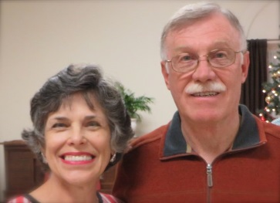
Pray for Our Missionaries
Martha and Will Faires
Myanmar

Will is a member of Catawba Valley Presbytery and has served about 16 years in Asia and 19 years at UNCC as a campus minister to international students.
Will began work with Equipping Leaders International in 2015. Equipping Leaders International trains national leaders in Asia, Africa, and India. Will has focused on Asia and is now director of the work in Myanmar, formerly called Burma.
Thank you all for your faithful partnership in the Gospel outreach to Myanmar.
I (Will) recently finished two Zoom conferences in Myanmar. The 12 hours of teaching covered Romans 1-8.
The second half of the course will be taught May 20/21 for one partner. The
other time is TBD. Please pray for Will and Martha and the work in Myanmar.

(Myanmar (formerly Burma) is a Southeast Asian nation of more than 100 ethnic groups, bordering India, Bangladesh, China, Laos and Thailand. Yangon (formerly Rangoon), the country's largest city, is home to bustling markets, numerous parks and lakes, and the towering, gilded Shwedagon Pagoda, which contains Buddhist relics and dates to the 6th century.)
Online Worship Service
Prosperity’s online Worship Service is available, and is on our Facebook Page - Prosperity Presbyterian Church at 10 AM. To view the service through our website check out https://www.prosperitypca.com/worship-services or listen to the sermon audio at “The Opportunists” Prosperity PCA

Please pray for the people in Ukraine.

Church Calendar
June 5, Sun. Worship Service
June 5, Sun. Inquirer’s Class
June 7, Tue. Trail Life 7:00 PM
June 8, Wed. Officer’s Training Class
June 21, Tue. Women Meet at Betty Wallace’ home

Church Families for Prayer
Sunday, June 5 Sarah Bosse
Monday, June 6 Inez Brown
Tuesday, June 7 Pastor Bruce and Family
Wednesday, June 8 John and Nicole Chiulli
Thursday, June 9 Olivia Clark
Friday, June 10 Jackie Clark
Saturday, June 11 Janice Connell

Love and Blessing Blankets

Tuesday, June 21 at 6 PM, at Betty Wallace’s home (14324 Eastfield Road.) Myra will demonstrate how to make a blanket (no sew) and everyone will help complete it. If time allows, we can make the second blanket. Myra will have a handout to give to you to take home with all instructions.
Please call Lucy (704) 345-2250 and let her know ASAP if you are coming.

Pollyanna (Secret Sisters) We will begin this project in July. Please let Lucy know if you are interested in this program (704) 345-2250.

* Brenda Anderson has been sick for several weeks. Please pray the doctors will find the cause and she will soon be well.

* Josie Barbee She is feeling much better, and is in Olde Knox Commons, 13825 Hunton Lane #6190, Room 601, Huntersville NC 28078. She asks that everyone continue to pray for her.

* JoAnne Perry is now at home (10001 John Adams Road, Charlotte, NC 28262). Pray for God's strength for JoAnne and granddaughter Melanie.

Trail Life, meets each Tuesday at 7:00 PM in the Gym. Open to boys ages 5-17. For information see Pastor Bruce.

Sunday School is taking a summer break
and will resume in late July.

