Church Directory

Staff

Pastor Rev. Bruce Brown
Office Administrator Dot Snyder
Preschool Director Isabelle Dontsop
Church Treasurer Earl Dove
Music Coordinator Brian Dove
Flower Coordinator Isabelle Dontsop
Prayer Chain Coordinator Brenda Anderson

Ruling Elders
Fred Entrekin 3/21 Elder
T. R. Hunter 3/21 Session Clerk
Joe Strube Elder Emeritus
Deacons
Earl Dove 10/23 Finance
Nelson Jenkins 3/21 Mercy
Johnny Wallace 3/21 Property
Raymond Wilson 3/21 Ushers, Property
Missionaries
Joe and Ann Lyle - MTW Taiwan
Larry and Sandra Rockwell–MTW Peru
Bill and Susan Carr – MTW Sioux Indians, MN
Michael and Lindie Wadhams-MTW Lummi Indians, WA
Shaun and Becky Hurrie – MTW South Africa

Need to Reach Us?

Rev. Bruce Brown ………………….………. christshousehold@yahoo.com

704-698-8009 cell

704-875-1182 ext. 6 church
Preschool….………………………..………….. Isabelle Dontsop - 704-947-0228
Dontsop cell 980-248-9306
E-mail……………………….…............ director@prosperitypreschool.com
Church Office…………………..…………..… 704-875-1182 Ext. 4
E-mail……………..…………..…………. email@prosperitychurch.org
Website…………………………………………. WWW.prosperitypca.com

Church Office Hours………..………..…... Tues.-Fri. 8:00 AM-12:30 PM
Prayer Chain Coordinator………………..Brenda Anderson
704-875-2351 - brendaea42@gmail.com

Welcome to Prosperity Church Service!

We warmly welcome you to the Prosperity Church Worship Service. We are honored to share this morning service with you as we worship God's risen Son. May you know the love of God and feel His presence, for you are special to the Lord, and to us. We pray that God will touch your life during the service, and that you will know His peace.

Sunday Morning Worship Service
Prosperity’s online Worship Service is available, and is posted on our Facebook Page - Prosperity Presbyterian Church at 10 AM. If you would like to view the service through our website check out https://www.prosperitypca.com/worship-services or listen to the sermon audio at “Dead and Buried” — Prosperity PCA

Wednesday Night Bible Study
The next Wednesday Night Bible Study is scheduled for April 7 at 7:00 PM. We will NOT meet March 31. Our lesson will be in chapters 15-16. The topic is “The Lawful Use of the Law.” We will meet in the sanctuary or you may continue to participate on Zoom.

Below is a link to our Bible Study on Zoom.
Call in Wednesday, April 7 around 6:55. The number is (408) 638-0968.
Once you place your call you will be asked to enter the meeting ID#. The ID# is 220 654 4063. After entering the ID# You will be asked to enter a participant ID, just skip this step by pressing the # button.
You can also join this meeting using your computer to join Zoom Meeting – via an Electronic Device (computer)
The link is https://us02web.zoom.us/j/2206544063. The ID is 220 654 4063.

Easter Services
At Prosperity Church
Good Friday Worship Service
April 2, 2021, 7:00 PM
Sunday Morning Worship
April 4, 2021, 10:00 AM

Pray for our Missionaries
Joe and Ann Lyle
Christ’s College, Taiwan
Joe and Ann have been in Taiwan with MTW since 1991. Their ministry with students at Christ’s College has involved teaching English, developing relationships, providing encouragement, evangelizing and mentoring.

Whether Joe and Ann are connecting with students in the classroom, on campus, or in their home, they encourage and challenge them to come to Christ, to grow in Him, and then to make disciples wherever they go.

The Lyles are now preparing to complete the spring semester at the college, and will leave Taiwan this summer. We look forward to meeting them here at Prosperity Church during our October Mission’s month. Please pray for Joe and Ann during this very difficult time of saying goodbye to those they have known and worked with for 30 years.

The February Treasurer’s Report is available if you would like to have a copy.

If you did not turn in your Sunday School Survey last week, please fill it in and give to an usher today.

Church Calendar
March 28, Sunday Worship Service at 10:00 AM
March 28, Sunday Congregational Meeting
March 30, Tuesday Trail Life
April 2, Friday Good Friday Worship Service
April 4 Sunday Easter Worship Service
April 11 Sunday Communion

Church Families for Prayer
Sunday, March 28 Olive McNeill
Monday, March 29 Joanne Perry
Tuesday, March 30 Ron and Lucy Richmond
Wednesday, March 31 Danny and Vicki Robbins
Thursday, April 1 Sandy Smith
Friday, April 2 Joe Strube
Saturday, April 3 Bernard and Jean Tilanus

Flowers
The beautiful flowers are given by Shelby Wallace to the glory of God and in loving memory of her parents Ted and Yvonne Taylor’s Wedding Anniversary. They were married March 31, 1944.
Congregational Meeting
Today, March 28 we will have a Congregational Meeting immediately following the Worship Service to reelect officers. The officers are: Ruling Elder Fred Entrekin – Deacons Johnny Wallace, Raymond Wilson.
Communion
We will celebrate communion Sunday, April 11.
Baby Gifts
A new baby is on the way! We will give the baby gifts and cards to Caleb and Brook Eldridge today.
Trail Life
Troop 412 meets each Tuesday at 7:00 PM in the GYM. This is a Christ-centered outdoor program open to boys and young men aged 5-17. If you have questions please see Pastor Bruce.
Flowers for the Outside Cross
On Easter Sunday you are invited to bring flowers and decorate the Outside Cross in front of the church. You need not purchase flowers, just bring whatever you have growing in your yard, dogwood, daffodils or wildflowers.
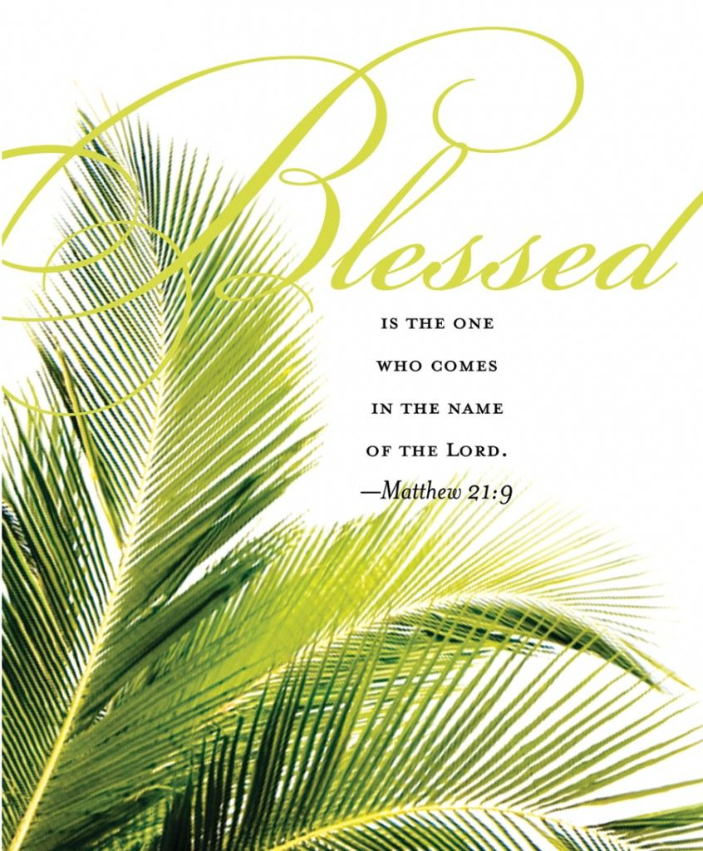

Palm Sunday
They brought the donkey and the colt, laid their clothes on them, and set Him on them. And a very great multitude spread their clothes on the road; others cut down branches from the trees and spread them on the road. Then the multitudes who went before and those who followed cried out, saying:
“Hosanna to the Son of David! Blessed is He who comes in the name of the LORD! Hosanna in the highest! And when He had come into Jerusalem, all the city was moved, saying, “Who is this?”
So the Multitude said, “This is Jesus, the prophet from Nazareth of Galilee.”

Based on Matthew 21:6-11

Palm Sunday
They brought the donkey and the colt, laid their clothes on them, and set Him on them. And a very great multitude spread their clothes on the road; others cut down branches from the trees and spread them on the road. Then the multitudes who went before and those who followed cried out, saying:
“Hosanna to the Son of David! Blessed is He who comes in the name of the LORD! Hosanna in the highest! And when He had come into Jerusalem, all the city was moved, saying, “Who is this?”
So the Multitude said, “This is Jesus, the prophet from Nazareth of Galilee.”

Based on Matthew 21:6-11

