Church Directory

Staff

Pastor Rev. Bruce Brown
Office Administrator Dot Snyder
Preschool Director Isabelle Dontsop
Church Treasurer Earl Dove
Music Coordinator Brian Dove
Flower Coordinator Isabelle Dontsop
Prayer Chain Coordinator Brenda Anderson

Ruling Elders
Fred Entrekin 3/24 Elder
T. R. Hunter Inactive
Joe Strube Elder Emeritus
Deacons
Earl Dove 10/23 Finance
Johnny Wallace 3/24 Property
Raymond Wilson 3/24 Ushers, Property
Missionaries
Joe and Ann Lyle - MTW Taiwan
Larry and Sandra Rockwell–MTW Peru
Bill and Susan Carr – MTW Sioux Indians, MN
Michael and Lindie Wadhams-MTW Lummi Indians, WA
Shaun and Becky Hurrie – MTW South Africa

Need to Reach Us?

Rev. Bruce Brown ………………….………. christshousehold@yahoo.com

704-698-8009 cell

704-875-1182 ext. 6 church
Preschool….………………………..………….. Isabelle Dontsop - 704-947-0228
Dontsop cell 980-248-9306
E-mail……………………….…............ director@prosperitypreschool.com
Church Office…………………..…………..… 704-875-1182 Ext. 4
E-mail……………..…………..…………. email@prosperitychurch.org
Website…………………………………………. WWW.prosperitypca.com

Church Office Hours………..………..…... Tues.-Fri. 8:00 AM-12:30 PM
Prayer Chain Coordinator………………..Brenda Anderson
704-875-2351 - brendaea42@gmail.com

Welcome to Prosperity Church Service!

We warmly welcome you to the Prosperity Church Worship Service. We are honored to share this morning service with you as we worship God's risen Son. May you know the love of God and feel His presence, for you are special to the Lord, and to us. We pray that God will touch your life during the service, and that you will know His peace.
Remember and Honor all who have served and sacrificed for our freedom.

May 31, 2021

“Our debt to the heroic men and valiant women in the service of our country can never be repaid.
They have earned our undying gratitude America will never forget their sacrifices." –
Harry S. Truman

Sunday School Meets Each Sunday
at 9 AM
Adult Sunday School
Next Sunday, June 6 we will study about “The Abrahamic covenant.” We meet in the sanctuary. All adults are invited to come study and pray with us.
Children’s Sunday School 6 to 12 years
Taught by Carol Comer in the Library …. Our children's class is continuing our study of Paul's letter to the Romans. Currently, Paul is explaining how Christians are to respond to God's mercies in their relationship to other believers.
Youth Sunday School 13 to 17 years
Taught by Tom Ellsworth …. We meet in Room #1 and are using the book “Treasuring God’s Word.”

Prosperity’s online Worship Service is available, and is posted on our Facebook Page - Prosperity Presbyterian Church at 10 AM. To view the service through our website check out https://www.prosperitypca.com/worship-services or listen to the sermon audio at “The Wonder of Following Christ”- Prosperity PCA
Wednesday Night Bible Study
June 2, at 7:00 PM. We meet in the sanctuary.
Our Wed. Bible Study is Daniel: A 12-Week Study.
Here is a link to our Bible Study on Zoom.
Call in Wednesday, June 2 around 6:55. The number is (408) 638-0968. Once you place your call you will be asked to enter the meeting ID#. The ID# is 220 654 4063. You will be asked to enter a participant ID, just skip this step by pressing the # button. You can also join this meeting using your computer to join Zoom Meeting – via an Electronic Device (computer)
The link is https://us02web.zoom.us/j/2206544063. The ID is 220 654 4063.

Remember the Carpet Fund. We now have $13,630.00. if you would like to give, make your check to the Carpet Fund and place it in the plate at the back of the church.

Church Calendar
May 30, Sunday Worship Service at 10:00 AM
May 30, Sunday Sunday School 9:00 AM
June 1, Tuesday Trail Life 7:00 PM
May 2, Wed. Bible Study – Daniel

Church Families for Prayer
Sunday, May 30 Leah Brant and Family
Monday, May 31 Bruce and Lily Brown Family
Tuesday, June 1 Jackie, Olivia and Sam Clark
Wednesday, June 2 Carol Comer
Thursday, June 3 Carolyn Davis
Friday, June 4 Isabelle Dontsop and Family
Saturday, June 5 Earl and Polly Dove

Pray for our Missionaries
Michael and Lindie Wadhams - Lummi Indians WA

We have been out of town preaching at new churches and sharing the ministry with potential churches. In spite of the continued lock downs in WA we are pressing ahead:
Pray for the following at Lummi:

1. The men’s Bible study is becoming a solid ministry that allows the native men to encourage and disciple each other. Pray for these men as they struggle with a host of social issues.
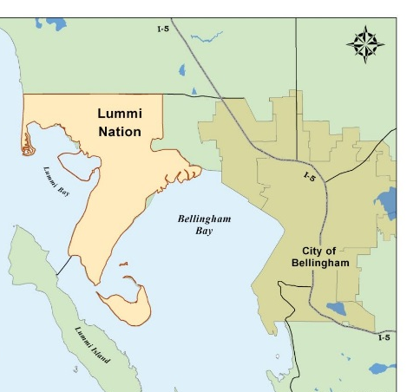
2. Lindie and Cindy (a team member) are trying to restart the Women’s Bible Fellowship.
3. We are trying to restart the soccer clinics with the Lummi afterschool programs.
MAP, The tribe primarily resides on and around the Lummi Indian Reservation, to the west of Bellingham and 20 miles (32 km) south of the Canadian border, in western Whatcom County.
Michael and Lindie Wadhams / E-mail: mission1968@hotmail.com

