Church Directory

Staff

Pastor Rev. Bruce Brown
Office Administrator Dot Snyder
Preschool Director Isabelle Dontsop
Church Treasurer Earl Dove
Music Coordinator Brian Dove
Flower Coordinator Isabelle Dontsop
Prayer Chain Coordinator Brenda Anderson

Ruling Elders
Fred Entrekin 3/24 Elder
Brian Dove 9/24 Elder – Session Clerk
T. R. Hunter Inactive
Joe Strube Elder Emeritus
Deacons
Earl Dove 10/23 Finance
Johnny Wallace 3/24 Property
Raymond Wilson 3/24 Ushers, Property
Ron Richmond 9/24 Mercy
Missionaries
Joe and Ann Lyle - MTW Taiwan
Larry and Sandra Rockwell–MTW Peru
Bill and Susan Carr – MTW Sioux Indians, MN
Michael and Lindie Wadhams-MTW Lummi Indians, WA
Shaun and Becky Hurrie – MTW South Africa

Need to Reach Us?

Rev. Bruce Brown ………………….………. christshousehold@yahoo.com

704-698-8009 cell

704-875-1182 ext. 6 church
Preschool….………………………..………….. Isabelle Dontsop - 704-947-0228
Dontsop cell 980-248-9306
E-mail……………………….…............ director@prosperitypreschool.com
Church Office…………………..…………..… 704-875-1182 Ext. 4
E-mail……………..…………..…………. email@prosperitychurch.org
Website…………………………………………. WWW.prosperitypca.com

Church Office Hours………..………..…... Tues.-Fri. 8:00 AM-12:30 PM
Prayer Chain Coordinator………………..Brenda Anderson
704-875-2351 - brendaea42@gmail.com

Welcome to Prosperity Church Service!

We warmly welcome you to the Prosperity Church Worship Service. We are honored to share this morning service with you as we worship God's risen Son. May you know the love of God and feel His presence, for you are special to the Lord, and to us. We pray that God will touch your life during the service, and that you will know His peace.

Welcome Larry and Sandy

Pray for our Missionaries
October is Missions Month and we have missionaries coming to Prosperity Church to share their ministry during the 10 AM Worship Service.

October 24: Larry and Sandy Rockwell
They have lived in Peru with the Quechua people for more than 17 years. He travels into the mountains to visit and shares God’s Word in their native Quechua language.

October 31: Rev. Will and Martha Faires
Will is with Equipping Leaders International (ELI). He has served about 14 years in Asia and 19 years at UNCC as a campus minister to international students.

Mission Books are available in the narthex and office hallway. Take a book and pray for our missionaries.

You may sign up in the narthex to receive newsletters from the Rockwells.

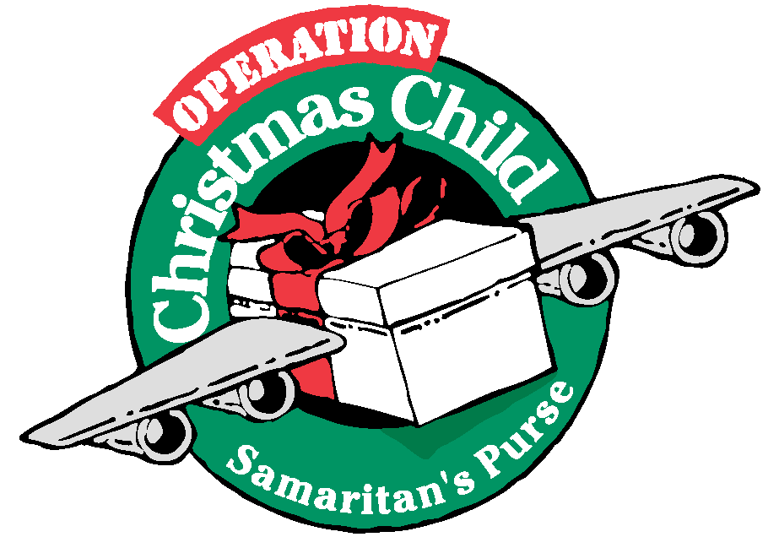
Operation Christmas Child
Shoeboxes are in the narthex. Please take as many as you can fill. A brochure “How to Pack a Shoebox” and boy/girl labels for your boxes, are also in the narthex. Shoeboxes must be in the Packing Center By November 14. Would you like to go with our group to the Packing Center to help pack the Shoeboxes? See Pastor Bruce.

Wednesday Night Bible Study
Gentle and Lowly
Wednesday, October 27, 7:00 PM.
We will be studying chapters 8 and 9.
Books are available in the narthex.
We will meet in the sanctuary.
Here is a link to our Bible Study on Zoom.
Call in Wednesday, Oct. 27. The number is (408) 638-0968. Once you place your call you will be asked to enter the meeting ID#. The ID# is 220 654 4063. After entering the ID# you will be asked to enter a participant ID, just skip this step by pressing the # button.
You can also join this meeting using your computer to join Zoom Meeting – via an Electronic Device (computer)
The link is https://us02web.zoom.us/j/2206544063. The ID is 220 654 4063.

Prosperity’s online Worship Service is available, and is on our Facebook Page - Prosperity Presbyterian Church at 10 AM. To view the service through our website check out https://www.prosperitypca.com/worship-services or listen to the sermon audio at “Suffering for the Lord’s Sake”- Prosperity PCA

Red Cross Blood Drive at Prosperity Church GYM Wednesday, December 15 from 9 AM to 1:00 PM. Be thinking about giving blood.
American Heritage Girls
The American Heritage Girls Organization meets the 1st, 3rd, and 5th Thursdays of each month at 7:00 PM in the GYM. The next meeting is Nov. 4. For information contact Megan Gregory.

Church Calendar
Oct. 24, Sunday Inquirer’s Class 9:00 AM
Oct. 24, Sunday Sunday School 9:00 AM
Oct. 24, Sunday Worship Service at 10:00 AM
Oct. 24, Sunday Larry and Sandy Rockwell 10:00 AM
Oct. 26, Tuesday Trail Life 7:00 PM
Oct. 27, Wednesday Bible Study 7:00 PM
Nov. 4, Thursday American Heritage Girls 7 PM

Church Families for PrayeR
Sunday, Oct. 24 Sarah Bosse
Monday, Oct. 24 Inez Brown
Tuesday, Oct. 24 Bruce and Lily Brown Family
Wednesday, Oct. 2 Jackie, Olivia, Sam Clark
Thursday, Oct. 24 Carol Comer
Friday, Oct. 24 Carolyn Davis
Saturday, Oct. 24 Isabelle Dontsop Family

Sunday School
Everyone is invited to come to Sunday School at 9:00 AM.
Adults have a class in the book of Hebrews, chapter 2:5-18:. “Hebrews: Better than Man” taught by Caleb Eldridge. This class meets in the sanctuary.
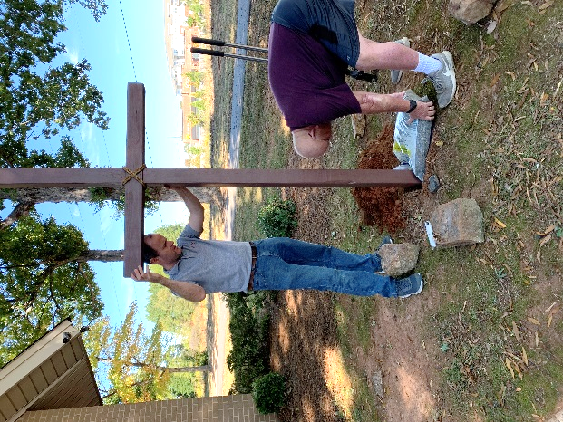
Children’s Class, ages 3-6, meets in the nursery and is taught by Megan Gregory. We are learning about How God Made all Things.
Children’s Class, age 7-12, meets in the Library and is taught by Carol Comer. The lessons are in I Corinthians.
Youth Class, ages 13-17, meets in Room #1 and is taught by Tom Ellsworth. The lessons are “Treasuring God’s Word.”
Mark Gregory helps teach the Youth and Children’s classes. New Church Cross!
Thank you Steve, Myra and Bruce

