Church Directory

Staff

Pastor Rev. Bruce Brown
Office Administrator Dot Snyder
Preschool Director Isabelle Dontsop
Church Treasurer Earl Dove
Music Coordinator Brian Dove
Flower Coordinator Isabelle Dontsop
Ruling Elders
Fred Entrekin 3/24 Elder
Brian Dove 9/24 Elder – Session Clerk
T. R. Hunter Inactive
Joe Strube Elder Emeritus
Deacons
Earl Dove 10/23 Finance
Johnny Wallace 3/24 Property
Raymond Wilson 3/24 Ushers, Property
Ron Richmond 9/24 Mercy
Missionaries
Larry and Sandra Rockwell–MTW Huaraz, Peru
Bill and Susan Carr – MTW West Fargo, ND
Michael and Lindie Wadhams-MTW Lummi Indians, WA
Shaun and Becky Hurrie – MTW South Africa
Frank and Sheree Newell – MTW Middle East
Will and Martha Faires – Myanmar, Burma - Equipping Leaders
Andrew Goyzueta – RUF Davidson College

Need to Reach Us?

Rev. Bruce Brown ………………………… christshousehold@yahoo.com

704-698-8009 cell

704-875-1182 ext. 6 church
Isabelle cell 980-248-9306
E-mail……………………….….................. director@prosperitypreschoChurch Office…………………..……………………..… 704-875-1182 Ext. 4
E-mail……………..…………..…………..…… email@prosperitychurch.org
Website………………………………………… WWW.prosperitypca.com

Church Office Hours………..………..…. Tues.-Fri. 8:00 AM-12:30 PM

Welcome to Prosperity Church Service!

We warmly welcome you to the Prosperity Church Worship Service. We are honored to share this morning service with you as we worship God's risen Son. May you know the love of God and feel His presence, for you are special to the Lord, and to us. We pray that God will touch your life during the service, and that you will know His peace.
M)

Daylight saving time will end this year on Sunday, Nov. 6, at 2 a.m. On Saturday night turn clocks back an hour (to 1 a.m.)

The beautiful flowers are in honor of NANCY NICAS. Happy birthday Mom and Nana. We thank God for the beautiful gift of you. We love you! Bruce, Lydia and Grand Kiddos.

Reformation Celebration Gathering
Sunday, October 30, at 5:30 PM in the Gym.
The Church congregation and its families are invited to a Reformation Celebration Gathering. Pastor Bruce will lead us in prayer with a short devotion. Children are free to wear costumes, but please nothing scary or inappropriate.
There will be a Chili/soup cook off, corn hole, lawn games and s’mores for all.
Please bring a pot of your favorite chili or soup to share.

RSVP to Lily Brown at 704-698-7830.

Operation Christmas Child v
Please take as many Shoeboxes as you can fill; take a boy or girl label to place on your box; after you have filled your box return it to the church. National Collection week is November 14-21.

Adult Sunday School
Our new Adult Sunday School Class is the Doctrine of God, entitled "God Is." The Word of God has so much to teach about what we are to believe concerning God. He has revealed Himself to us, in His Word and Works. And as A.W. Tozer once said - "What comes into our minds when we think about God is the most important thing about us.” Plan to join us as we mine the Scriptures for a better knowledge of our God and King!

American Heritage Girls meet at 6:30 November 3 at the gym.

Trail Life meets each Tuesday at 7:00 PM in the GYM. This is a Christ-centered outdoor program open to boys and young men aged 5-17.

The next Ladies Bible Study will meet November 2 in the sanctuary.

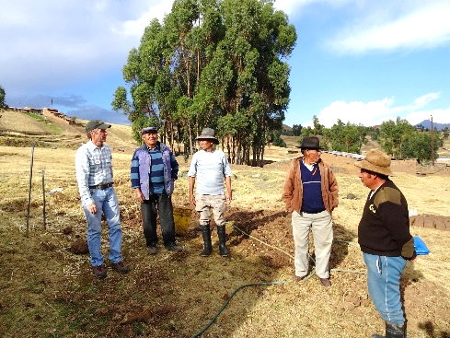
October is Mission’s Month
Please pray for Larry and Sandy Rockwell – Huaraz, Peru
Larry and Sandy Rockwell have been serving among the Quechua people in the Andes Mountains of Peru since 2004. They are located in the city of Huaraz at an altitude of almost 10,000 feet. The Rockwell’s primary ministry focus is evangelism, discipleship and church planting among the unchurched Quechua people group in the high isolated mountain villages of the Andes. Although the work remains difficult, the Rockwell’s have continued to build relationships through Larry’s proficiency in the Quechua language.
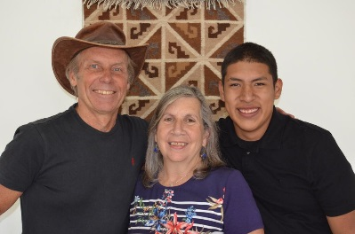
Doing evangelism and discipleship in this culture often means meeting people where they are at which many times means coming alongside them as they are working in their fields, giving them rides into or out of their villages or sitting and talking with them in the main plaza of the village. Another aspect of their ministry is maintaining and managing MTW’s Huaraz Center where they host short-term teams, seminars for local pastors and church leaders, along with implementing conservation farming techniques for demonstration purposes.
Larry and Sandy

Church Calendar
Oct. 30, Sun. Worship Service 10:00 AM
Oct. 30, Sun. Sunday School 8:55 AM
Nov. 1, Tue. Trail Life 7:00 PM
Nov. 2, Wed. Ladies Bible Study 9:10 AM
Nov. 3, Thur. American Heritage Girls 6:30 PM
Church Families for Prayer
Sunday, Oct. 30 Ron and Lucy Richmond
Monday, Oct. 31 Danny and Vicki Robbins
Tuesday, Nov. 1 Joel and Shelley Ross
Wednesday, Nov. 2 Sandy Smith
Thursday, Nov. 3 Joe Strube
Friday, Nov. 4 Bernard and Jean Tilanus
Saturday, Nov. 5 Betty Wallace
* Please pray for Sandy Smith as changes are made and for good health.
* Vicki Robbins Please continue praying for Vicki that she will be completely well.
* Brenda Anderson - Please pray for Brenda. Pray that her memory will improve, and she will be well again.
* Please continue to pray for the T. R. and Alma Hunter family.
* Pray for Josie Barbee, Bernard Tilanus and Lorraine Gould she was in a wreck and her car was badly damaged. She is feeling some better now.
Outreach Program Hope Street Food Pantry (container is located in the narthex.) We are collecting food items now through November 14. Items needed are: Turkey stuffing, instant mashed potatoes, mac and cheese, corn, green beans, gravy, cake mix and icing. (Lucy)
Online Worship Service
Prosperity’s online Worship Service is available, and is on our Facebook Page-Prosperity Presbyterian Church at 10 AM. To view the service through our website check out https://www.prosperitypca.com/worship-services or listen to the sermon audio at “Living for the Day of the Lord” Prosperity PCA.

Missions Books are available in the narthex and office hallway; adults please take one per family. Children please share with parent.

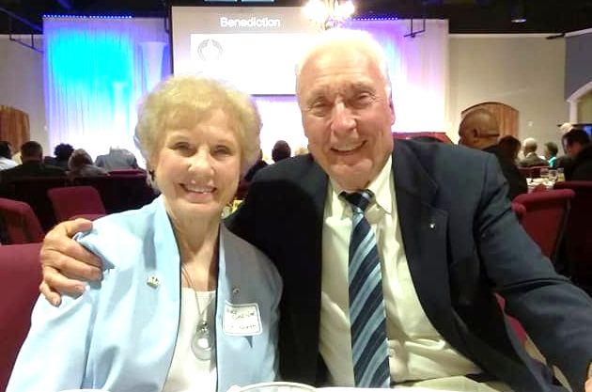

Welcome Jim and Nancy Garner

Most of you have heard of The Gideon’s International. You have seen their Bibles and Testaments in Motels and Hotels, in the military, or in school or on a college campus. But you may never have known that this association of Christian Business and Professional men, and their wives, is actually a missionary arm of our church.

Jim Garner, Pastor Relations Chairman, Charlotte, North Camp, has come our way this morning to present a report of how God is blessing His Word as it goes forth around the world, through this cost effective association.

By profession Jim was in Industrial Relations and Sales. Jim and his Wife, Nancy, are members of Hickory Grove Baptist Church. Jim and Nancy just renewed their wedding vows after 25 years of marriage and have served for more than 20 years in the Gideon’s Ministry, with an emphasis on Pastor and Church Relations.

Welcome Jim and Nancy Garner

Most of you have heard of The Gideon’s International. You have seen their Bibles and Testaments in Motels and Hotels, in the military, or in school or on a college campus. But you may never have known that this association of Christian Business and Professional men, and their wives, is actually a missionary arm of our church.

Jim Garner, Pastor Relations Chairman, Charlotte, North Camp, has come our way this morning to present a report of how God is blessing His Word as it goes forth around the world, through this cost effective association.

By profession Jim was in Industrial Relations and Sales. Jim and his Wife, Nancy, are members of Hickory Grove Baptist Church. Jim and Nancy just renewed their wedding vows after 25 years of marriage and have served for more than 20 years in the Gideon’s Ministry, with an emphasis on Pastor and Church Relations.

