Church Directory

Staff

Pastor Rev. Bruce Brown
Office Administrator Dot Snyder
Preschool Director Isabelle Dontsop
Church Treasurer Earl Dove
Music Coordinator Brian Dove
Flower Coordinator Isabelle Dontsop
Prayer Chain Coordinator Brenda Anderson

Ruling Elders
Fred Entrekin 3/24 Elder
Brian Dove 9/24 Elder
T. R. Hunter Inactive
Joe Strube Elder Emeritus
Deacons
Earl Dove 10/23 Finance
Johnny Wallace 3/24 Property
Raymond Wilson 3/24 Ushers, Property
Ron Richmond 9/24 Mercy
Missionaries
Joe and Ann Lyle - MTW Taiwan
Larry and Sandra Rockwell–MTW Peru
Bill and Susan Carr – MTW Sioux Indians, MN
Michael and Lindie Wadhams-MTW Lummi Indians, WA
Shaun and Becky Hurrie – MTW South Africa

Need to Reach Us?

Rev. Bruce Brown ………………….………. christshousehold@yahoo.com

704-698-8009 cell

704-875-1182 ext. 6 church
Preschool….………………………..………….. Isabelle Dontsop - 704-947-0228
Dontsop cell 980-248-9306
E-mail……………………….…............ director@prosperitypreschool.com
Church Office…………………..…………..… 704-875-1182 Ext. 4
E-mail……………..…………..…………. email@prosperitychurch.org
Website…………………………………………. WWW.prosperitypca.com

Church Office Hours………..………..…... Tues.-Fri. 8:00 AM-12:30 PM
Prayer Chain Coordinator………………..Brenda Anderson
704-875-2351 - brendaea42@gmail.com

Welcome to Prosperity Church Service!

We warmly welcome you to the Prosperity Church Worship Service. We are honored to share this morning service with you as we worship God's risen Son. May you know the love of God and feel His presence, for you are special to the Lord, and to us. We pray that God will touch your life during the service, and that you will know His peace.

Inquirer’s Class
Pastor Bruce is teaching the Inquirer’s Class September 26, Oct. 3, and 10 at 9 AM. If you would like to become a member of Prosperity Church, or just wish to know more about the church you are welcome to attend. We have 12 people signed up to attend this class. If you did not sign, but would like to attend see Pastor Bruce.

Sunday School
We are having a wonderful time in Sunday School. If you have not attended please plan to attend. We have fellowship and then study God’s Word.
Adults have a class in the book of Hebrews, chapter 1:4-14 “Better than Angels” taught by Caleb Eldridge (while Pastor Bruce is teaching the Inquirer’s Class). This class meets in the sanctuary.
Youth Class, ages 13-17, meets in Room #1 and is taught by Tom Ellsworth. The lessons are “Treasuring God’s Word.”
Children’s Class, age 7-12, meets in the Library and is taught by Carol Comer. The lessons are in I Corinthians.
Mark Gregory helps teach the Youth and Children’s classes.

Announcements

Operation Christmas Child
It’s time to again begin thinking about Operation Christmas Child. Now is a great time, with back to school sales, to purchase the gifts to put in the boxes. We will soon have empty boxes for you. Filled boxes must be in the Packing Center November 15-22, and the center will need volunteers to help pack.

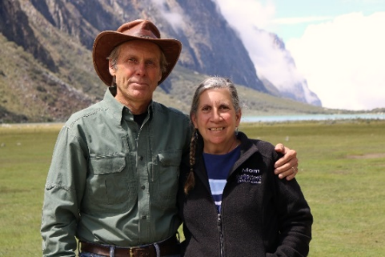
Pray for our Missionaries
Larry, Sandy and Jonathan
Huaraz, Peru
Larry goes many miles into the mountains to talk with the native people. Some of them are planting potatoes, some are working at other crops in the fields, but they stop and talk with him about the Bible. Countless times Larry encounters people who do not believe the inspired inerrancy of God’s Word. Most people in the Quechua communities do not believe in an afterlife. Sadly their hope, is to survive by working hard to produce enough food for their families.
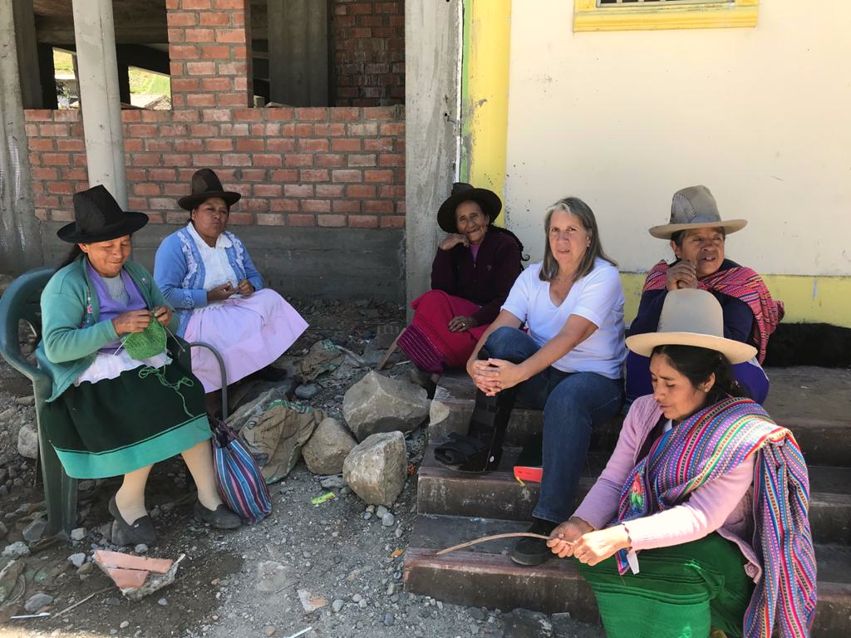
Larry is always hopeful that the seeds that have been planted in the lives of the Quechua people will bear fruit in a life redeemed. With each person he meets and each opportunity that God provides to share the truth of the gospel, he is trusting that the Holy Spirit is at work and will use His Word to touch hearts and change lives.
Sandy’s health has improved, and her headaches are getting better.
Thank you so much for standing with us in bringing the word of God to the Quechua in their heart language. Larry, Sandy

October is Mission’s Month and we will have missionaries visiting and speaking at Prosperity Church.

Church Calendar
Sept. 19, Sunday Worship Service at 10:00 AM
Sept. 21, Tuesday Trail Life 7:00 PM
Sept. 26 Sunday Officer’s Meeting 6 PM
Sept. 30, Thursday American Heritage Girls 7 PM
Communion - We will observe Communion October 3
The Wednesday Bible Study will resume October 6

Church Families for PrayeR
Sunday, Sept. 19 Armando and Eunice Hernandez Family
Monday, Sept. 20 T. R. and Alma Hunter
Tuesday, Sept. 21 Gypsy Keith
Wednesday, Sept. 22 Bob Kidder
Thursday, Sept. 23 Nancy Lindley
Friday, Sept. 24 Gerald and Argie Locklear
Saturday, Sept. 25 Nancy McAuley

Pray for Mary Sue Mundorf that her foot problems will heal. Pray for the doctors to have wisdom in treating her.

Prosperity’s online Worship Service is available, and is on our Facebook Page - Prosperity Presbyterian Church at 10 AM. To view the service through our website check out https://www.prosperitypca.com/worship-services or listen to the sermon audio at “So Great a Salvation!”- Prosperity PCA
Trail Life - Troop 412 meets each Tuesday at 7:00 PM in the GYM. This is a Christ-centered outdoor program open to boys and young men aged 5-17. If you have questions please see Pastor Bruce.

Wednesday Night Bible Study Gentle and Lowly By Dane C. Ortlund - Books are available; please take one. The new Wednesday Night Bible Study will begin October 6.

The American Heritage Girls Organization meets the 1st, 3rd, and 5th Thursdays of each month at 7:00 PM in the GYM. The meeting is September 30. For information contact Megan Gregory.

The Church Officers will have a meeting Sept. 26 in the Library at 6 PM.

